**SQL:**

**SQL Commands:**

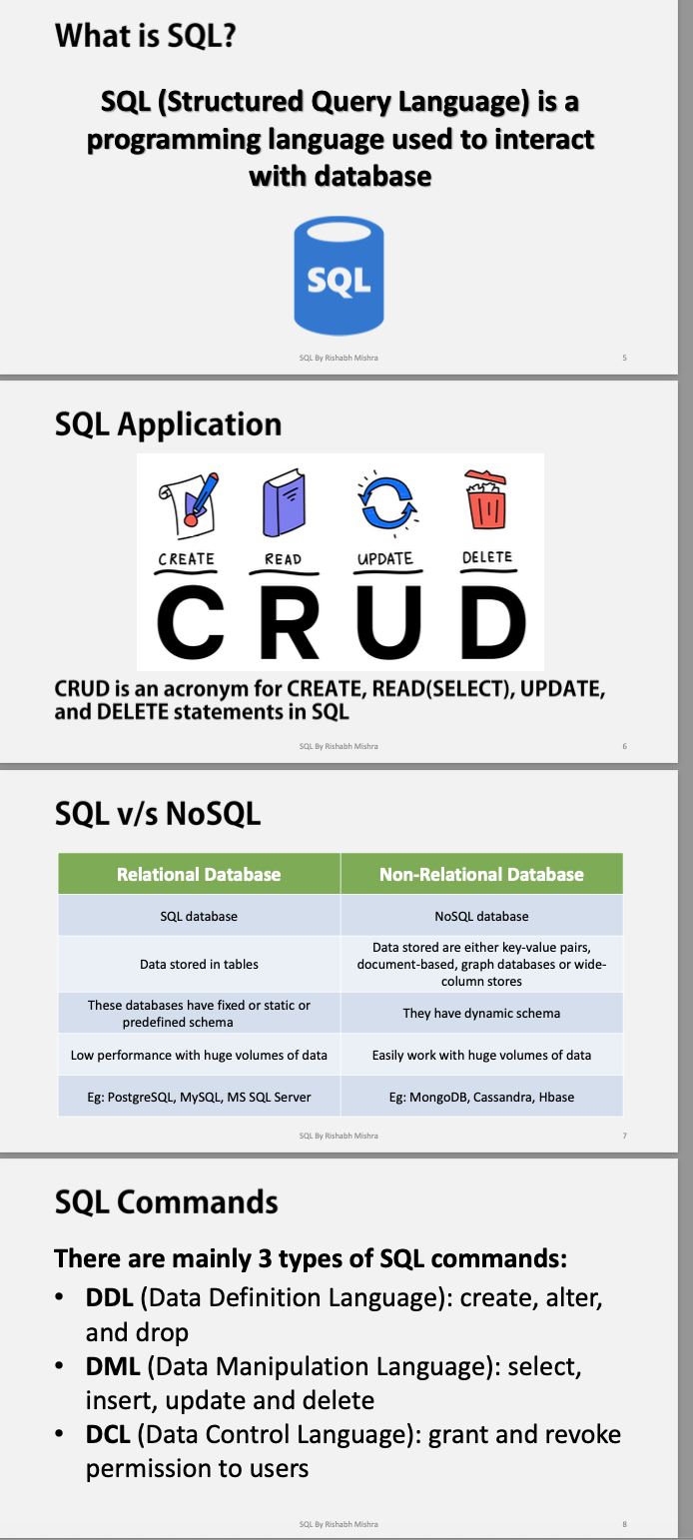

**Database:**

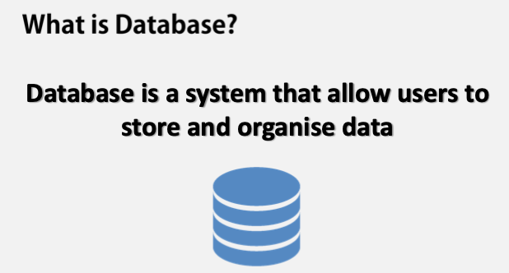

**SQL Structure:**

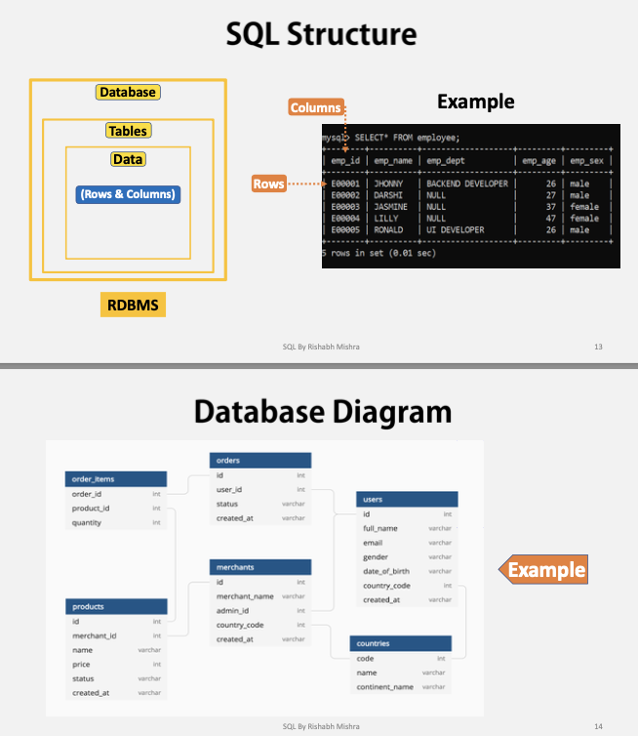

**Data Types:**

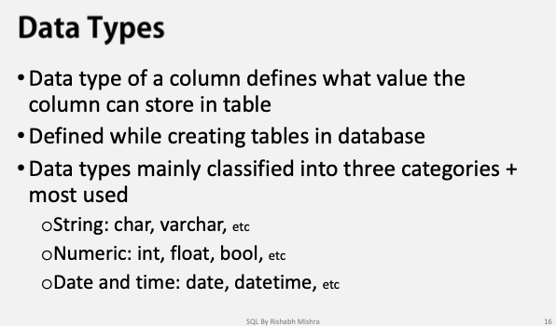

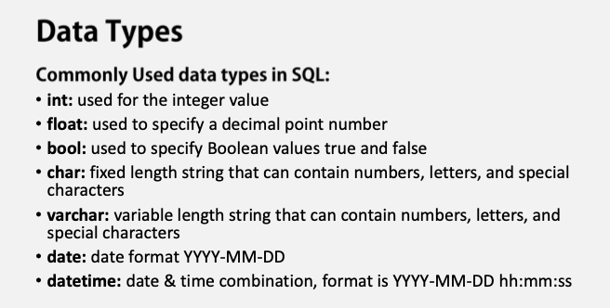

**Constraints: It is always added at the end**

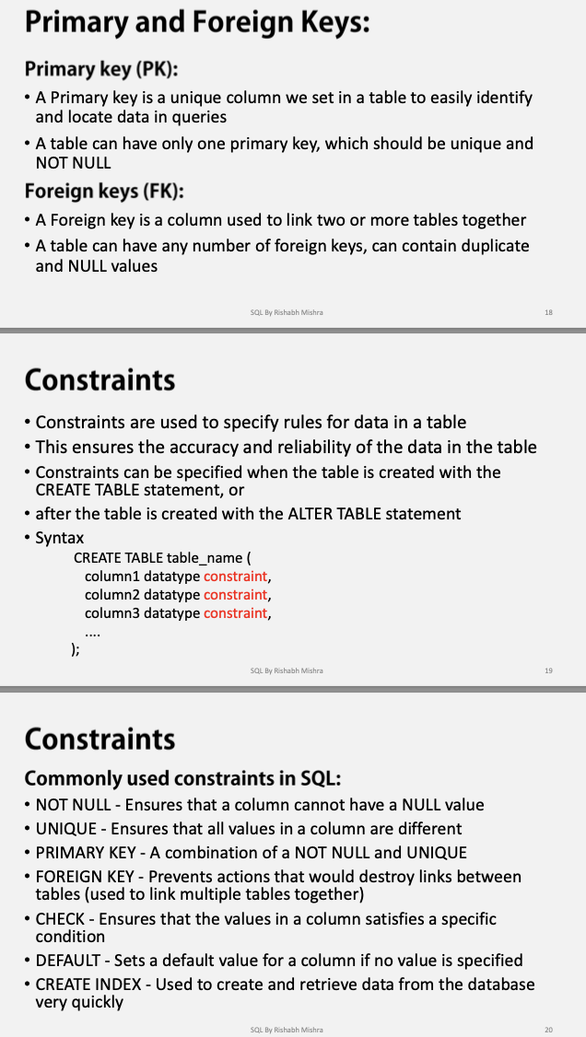

**Create Table Example:**

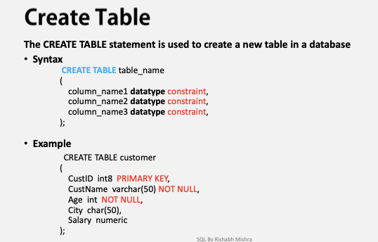

**Insert & Update example:**

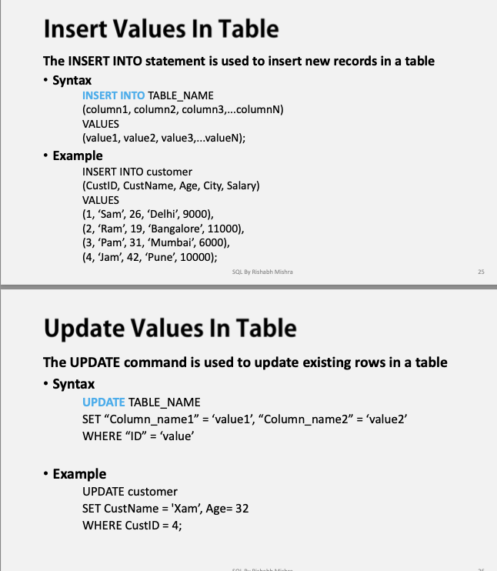

**Alter & Delete Examples:**

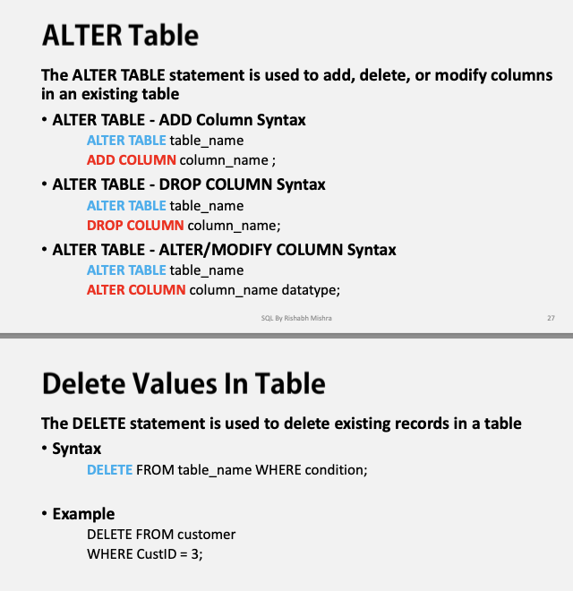

**Alter Command updated one:**

**alter table customer alter column address_id set data type int;**

**Drop & truncate:**

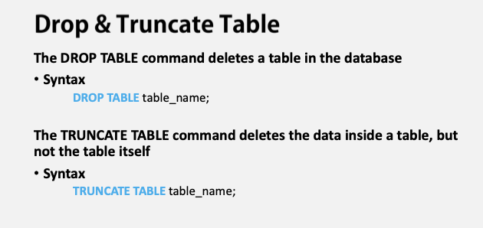

**Select Statements:**

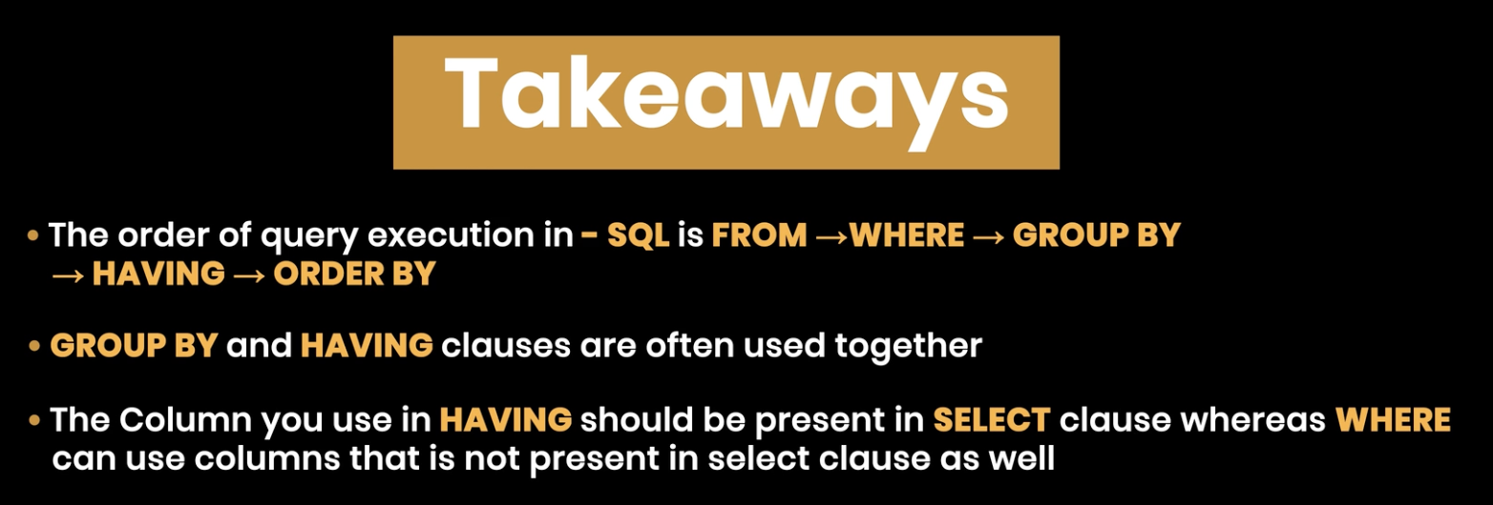

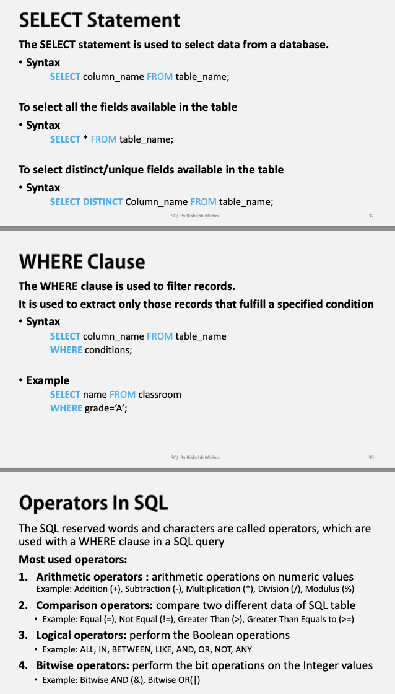

**Operators**

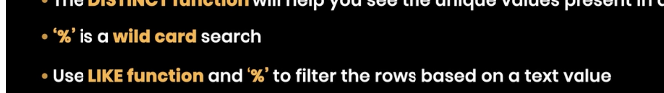

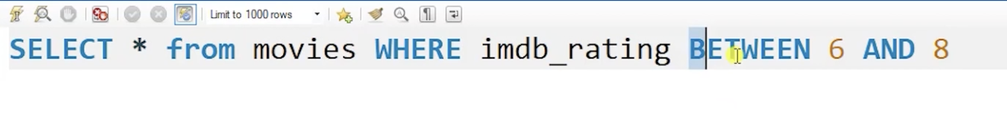

### Example:

sql

Copy

SELECT * FROM products

WHERE price BETWEEN 10 AND 50;

In this example, the query will return products where the price is **greater than or equal to 10** and **less than or equal to 50**.

Offset:

### Example:

Let’s assume we have a customers table with 100 rows, and we want to get rows 21 through 40:

sql

Copy

SELECT *

FROM customers

ORDER BY customer_id

LIMIT 20 OFFSET 20;

### Explanation:

* **LIMIT 20**: Return 20 rows.
* **OFFSET 20**: Skip the first 20 rows.

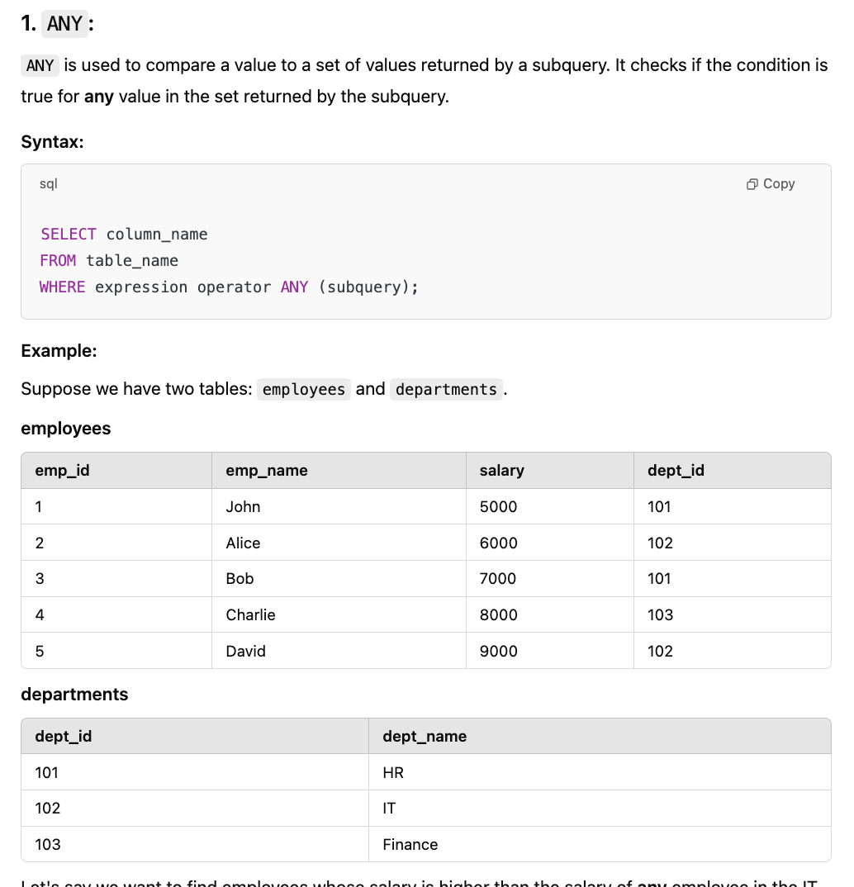

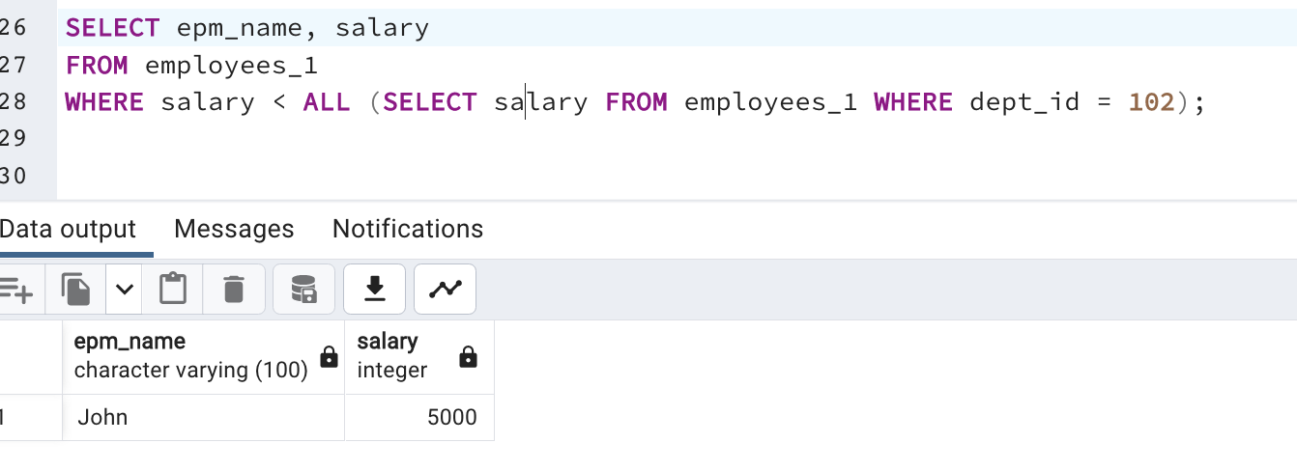

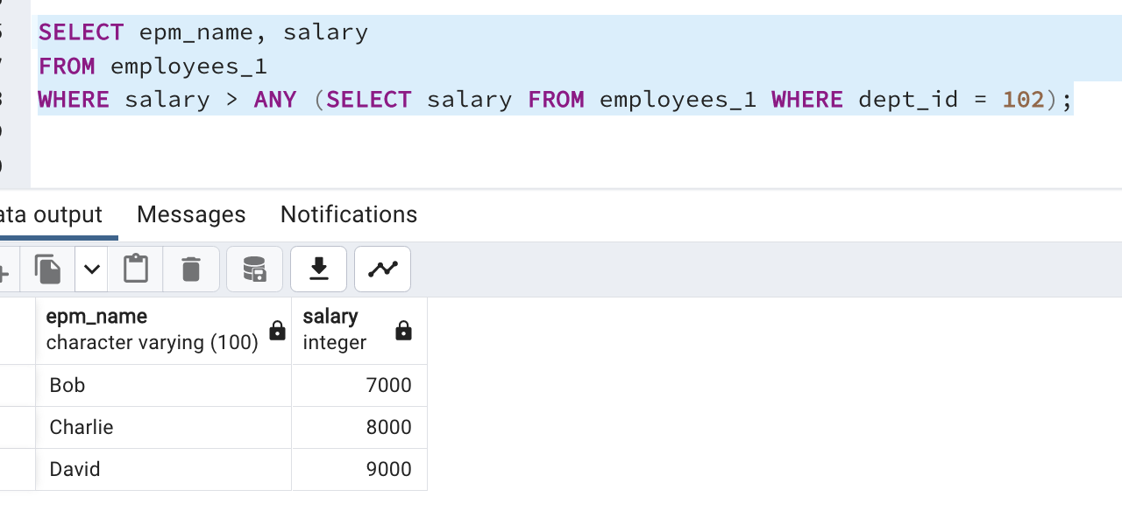

**Limit & Orderby:**

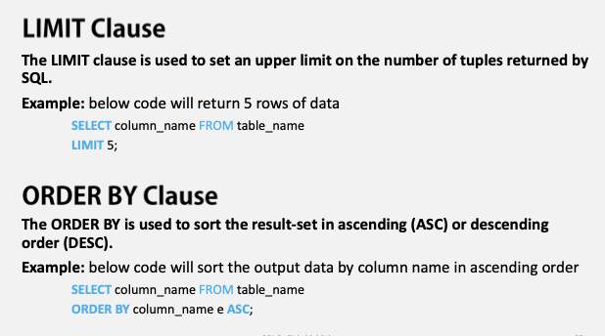

**Functions:**

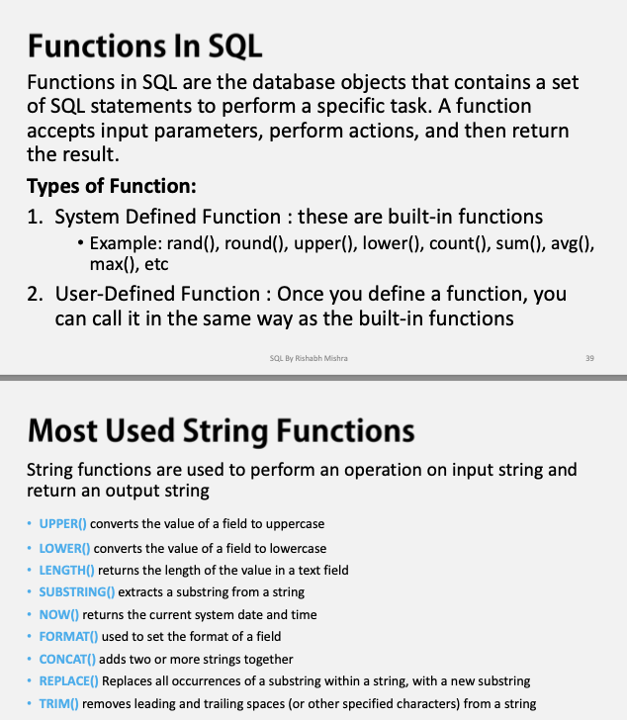

**Co-related Subquery:**

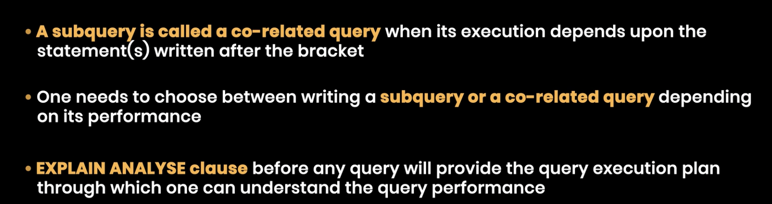

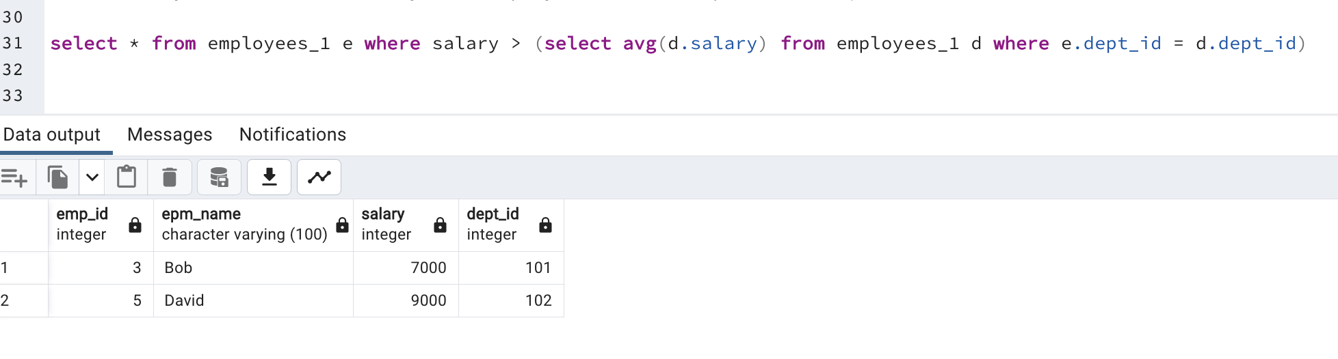

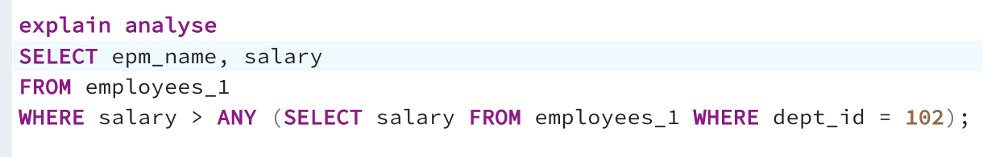

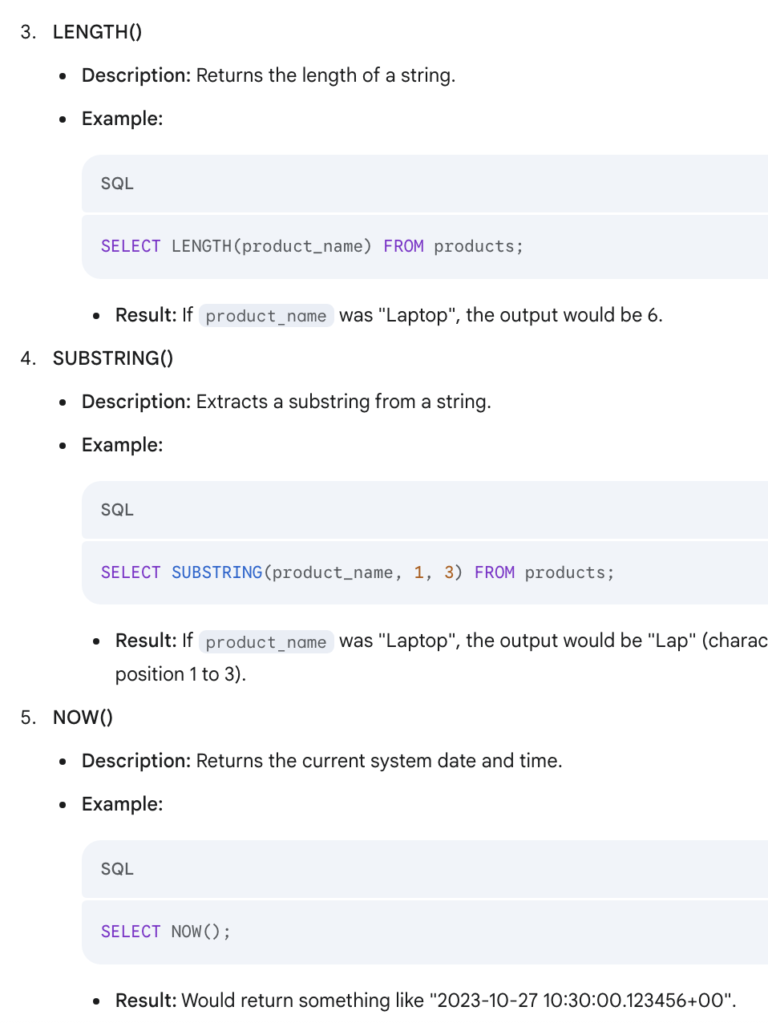

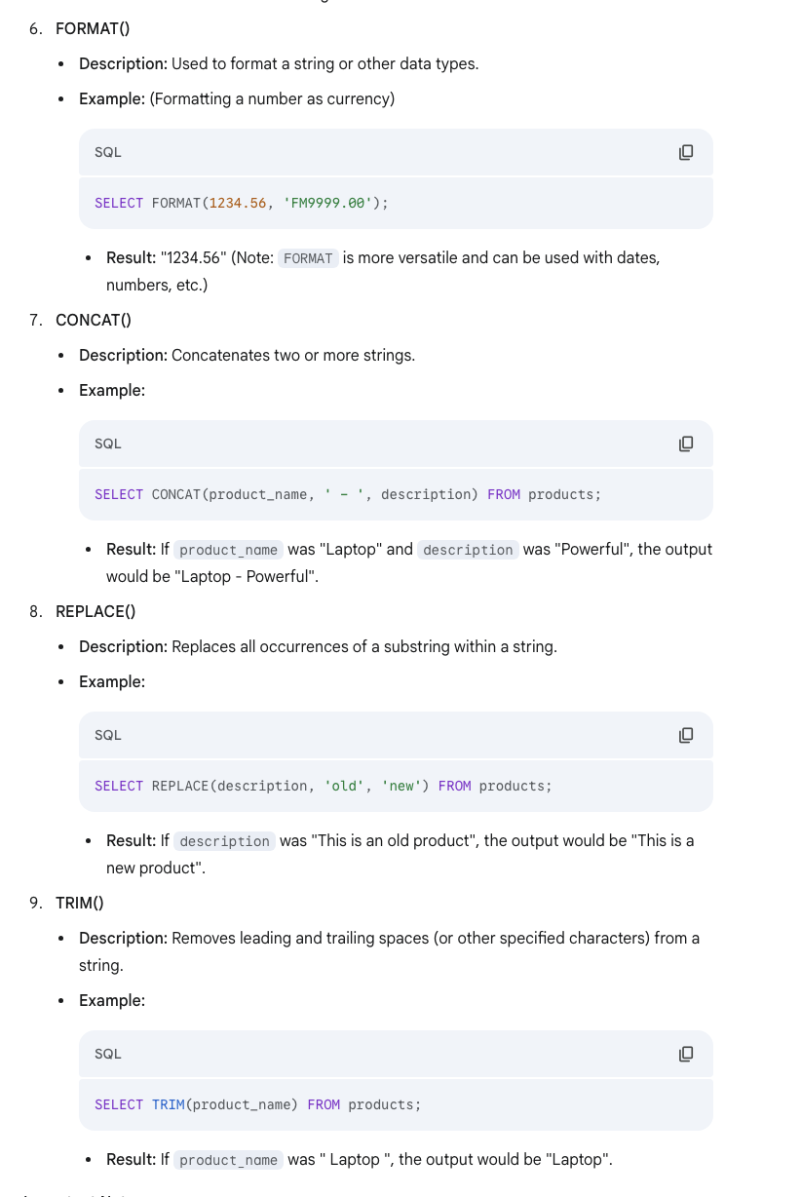

**Normalization:**

DataBase Design:

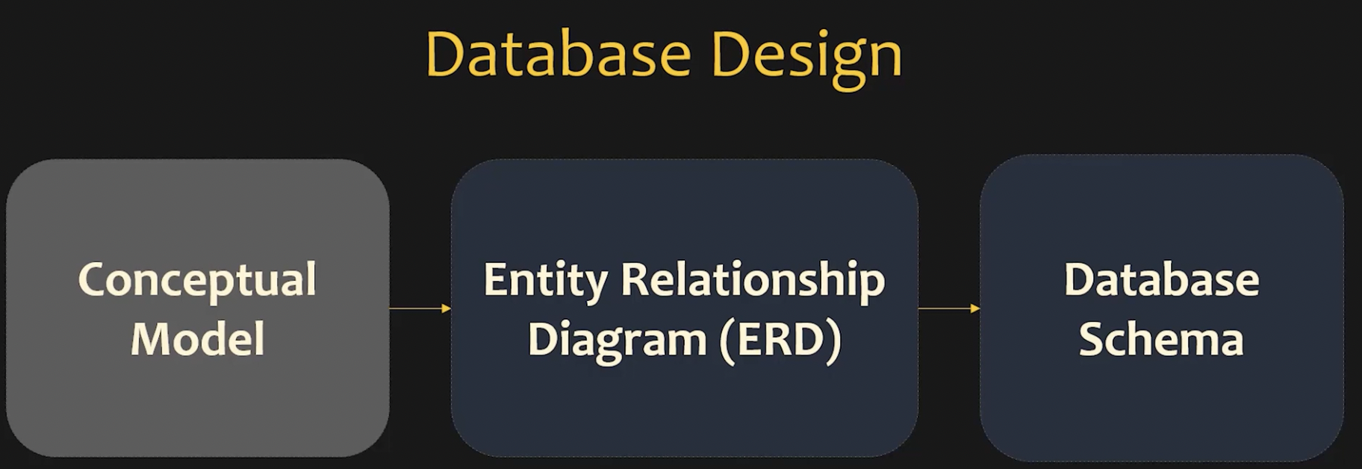



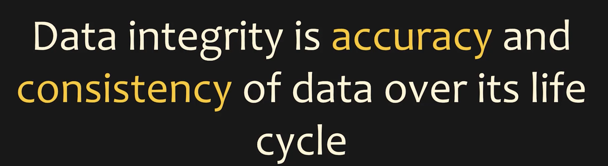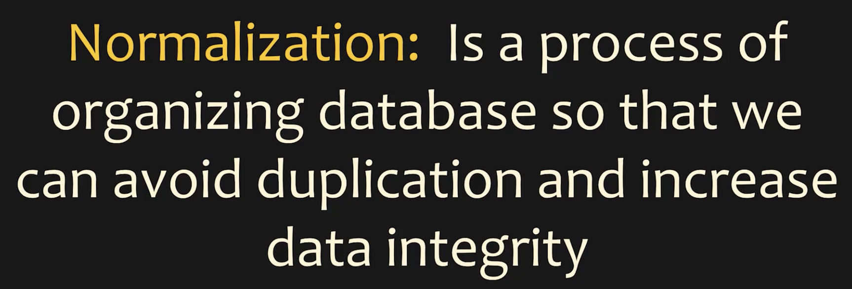

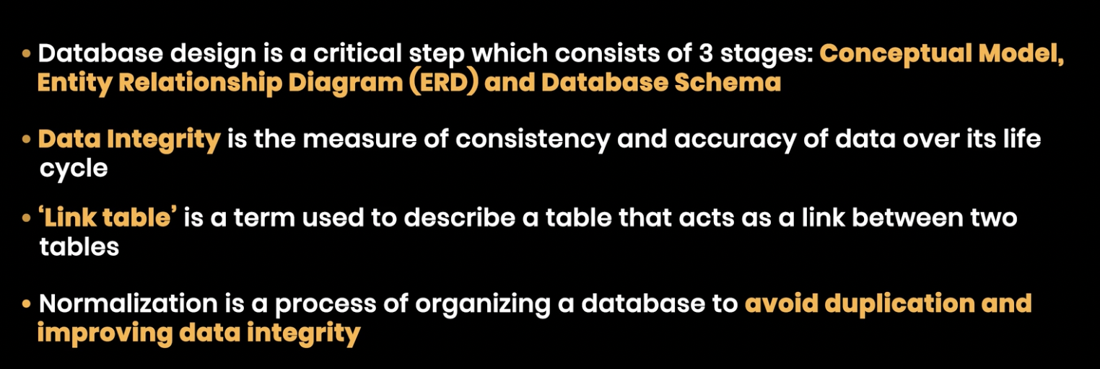

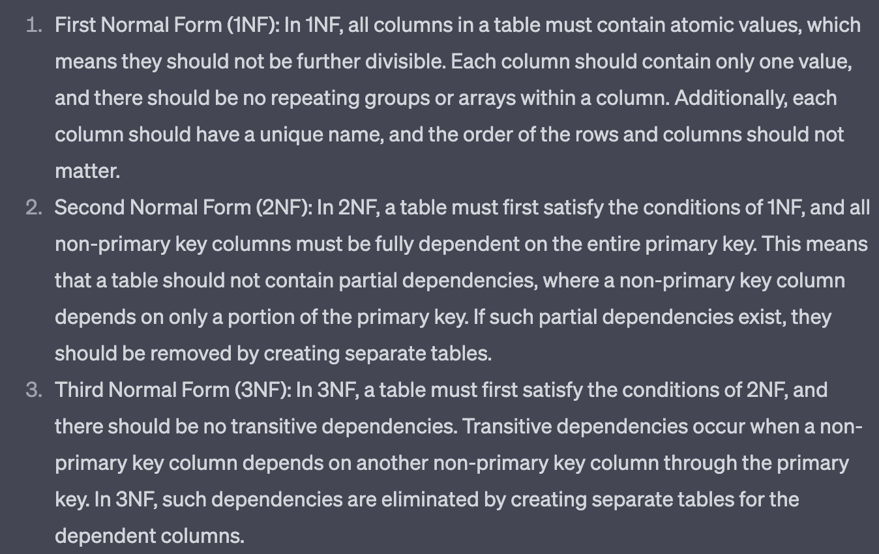

**Aggregate Functions:**

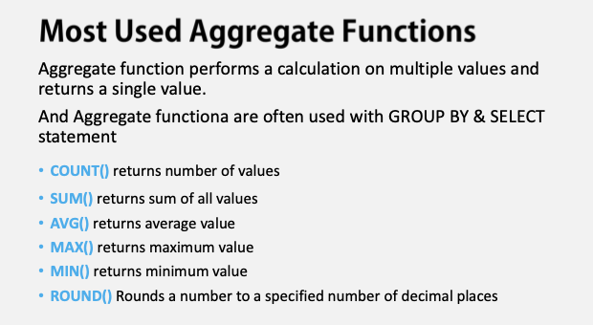

**Group By & Having:**

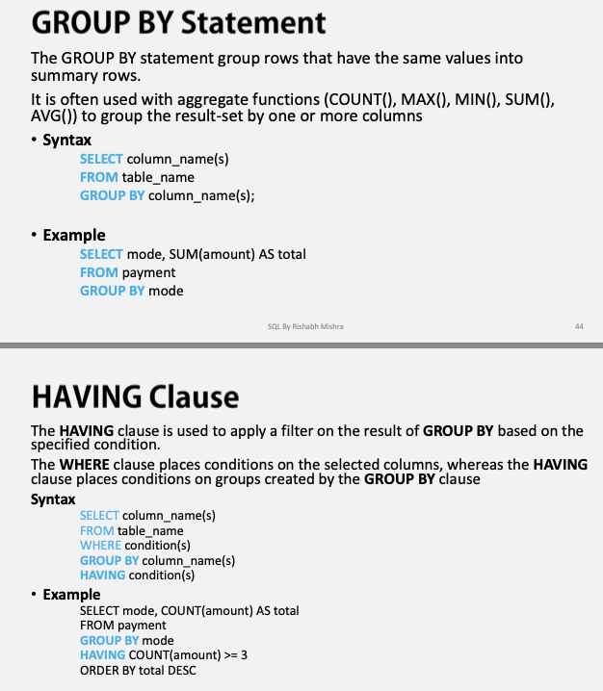

**Whatever columns present in select side same column should be there in group by**

**Timestamp Datatype:**

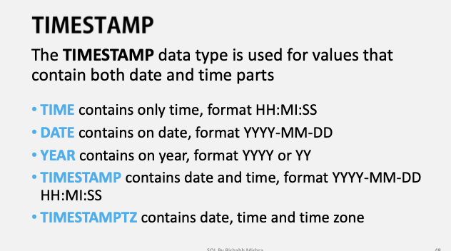

**Timestamp Functions:**

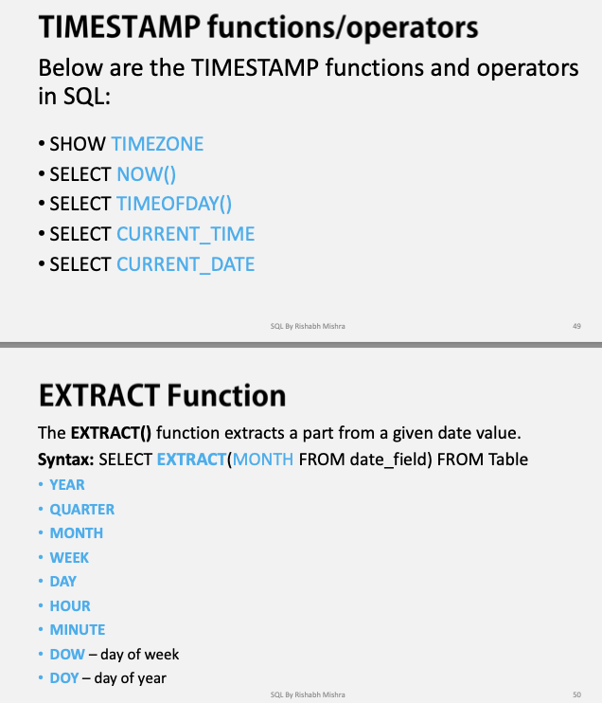

**Joins:**

Cross Join:

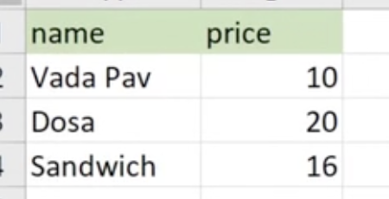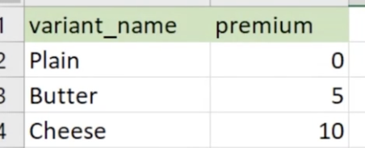

Final Result

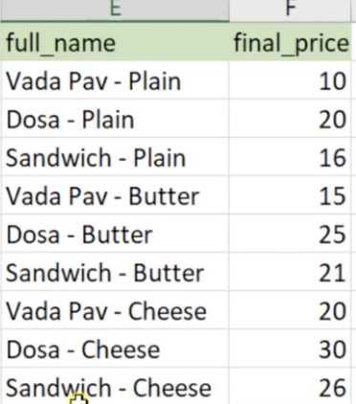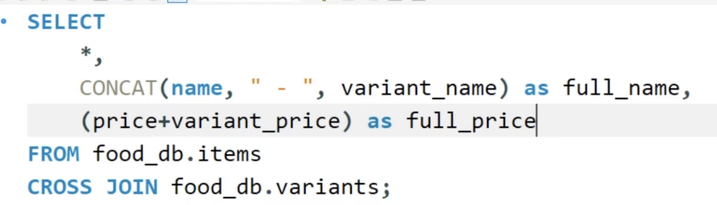

**Normalization:**

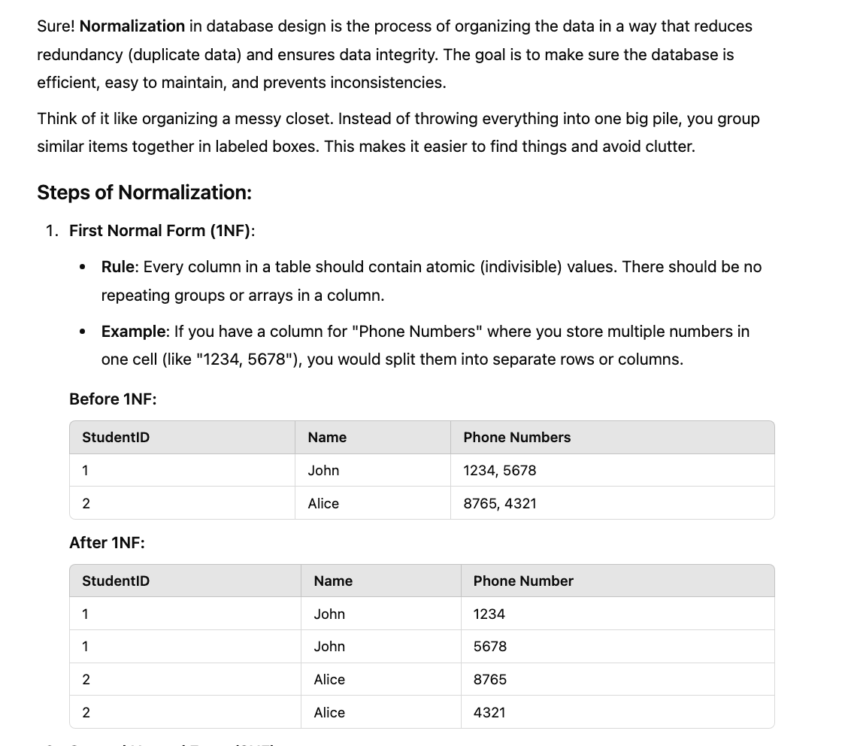

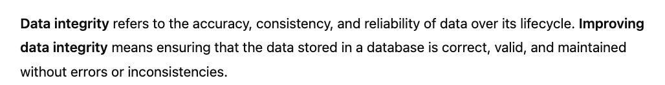

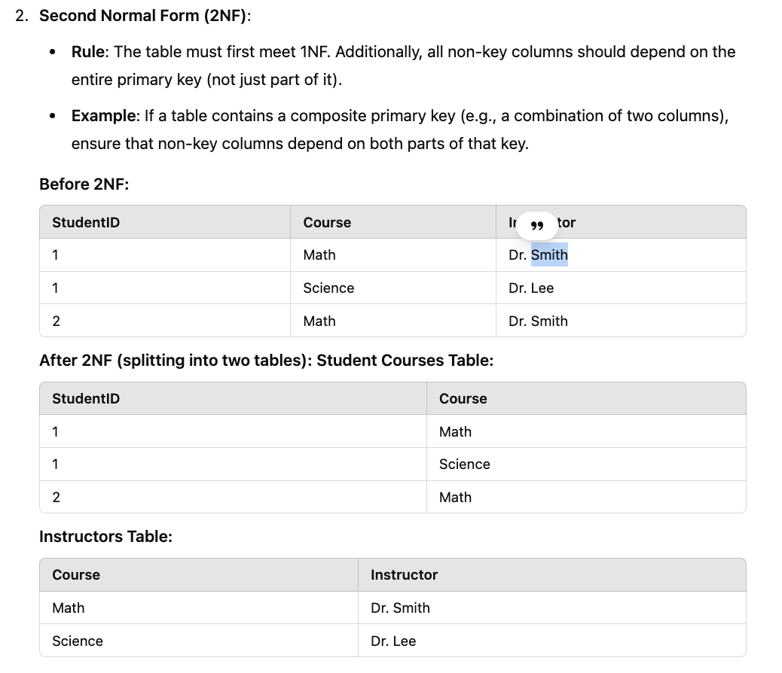

Non-key column are nothing but non primary keys

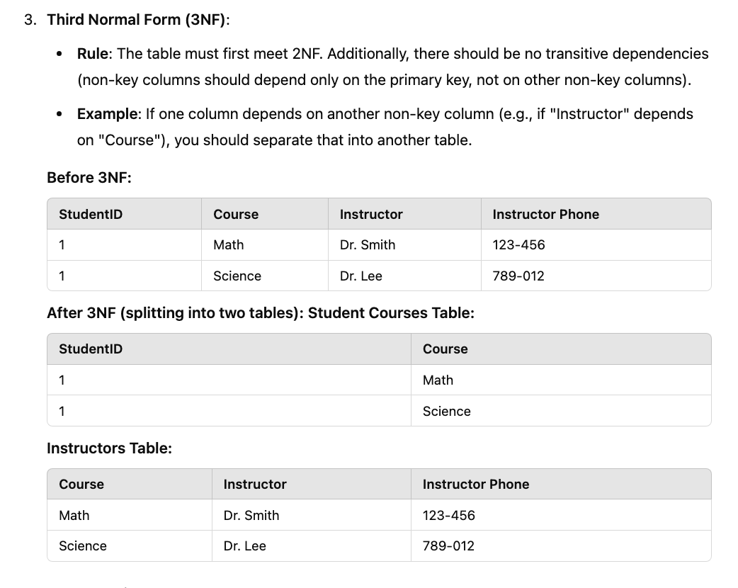

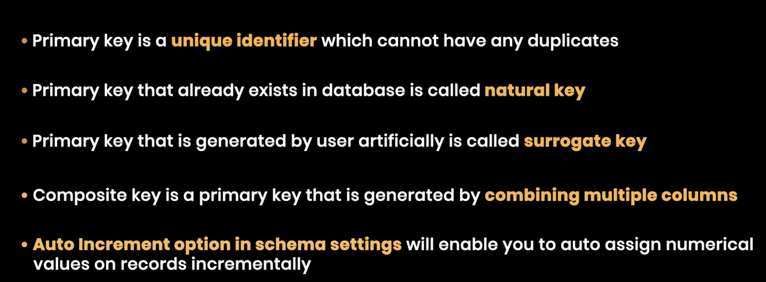

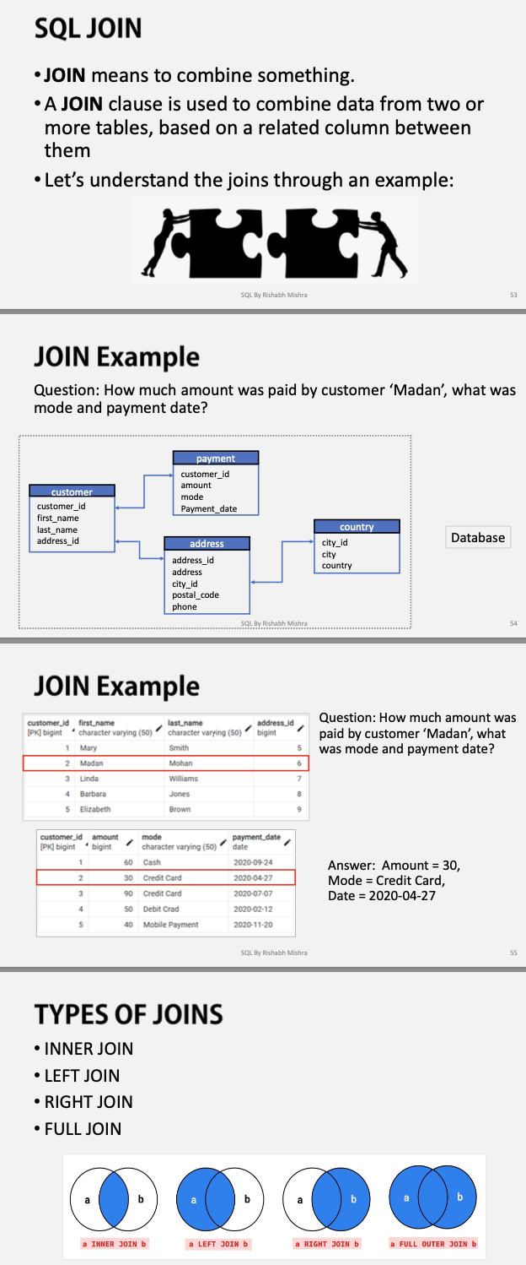

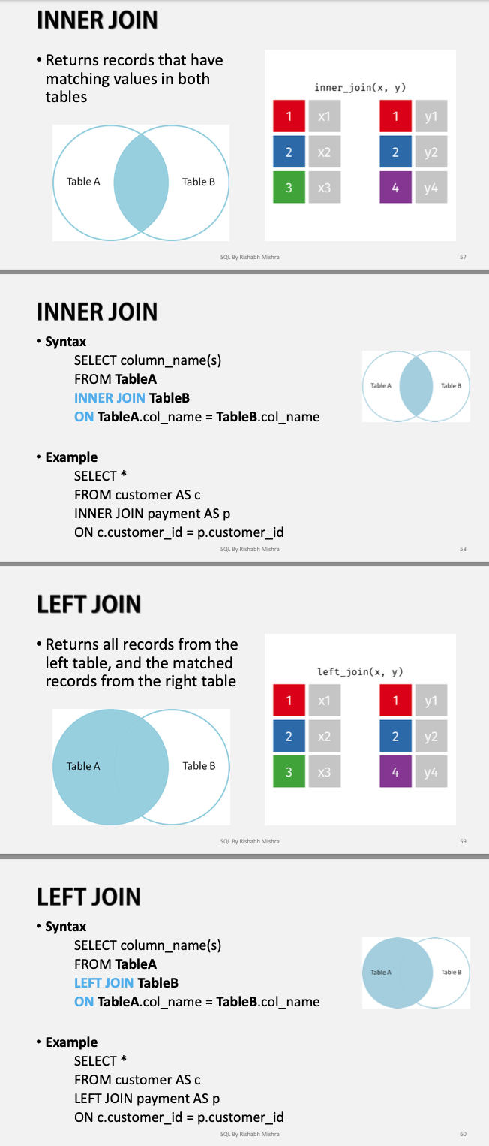

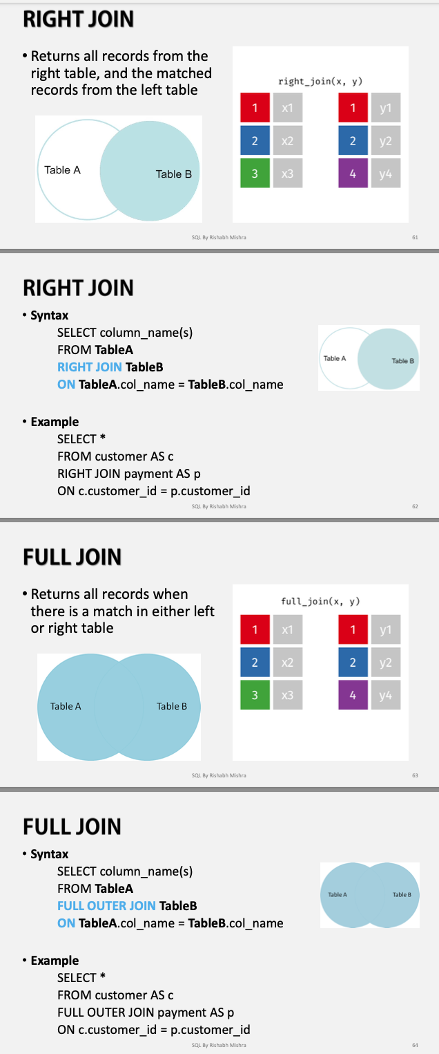

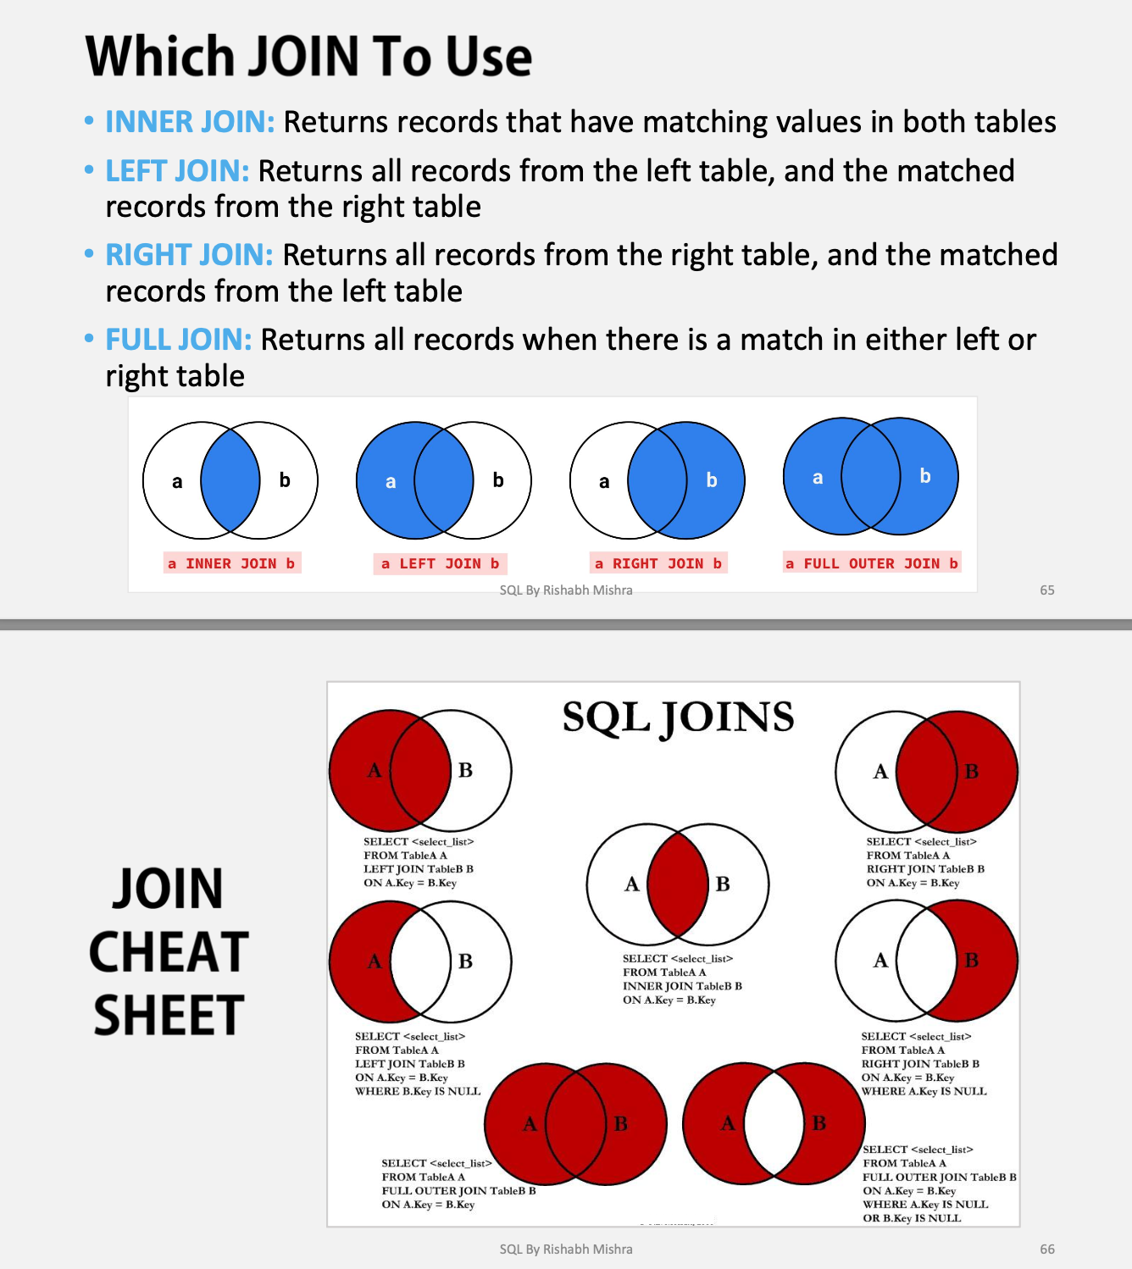

**Self Join:**

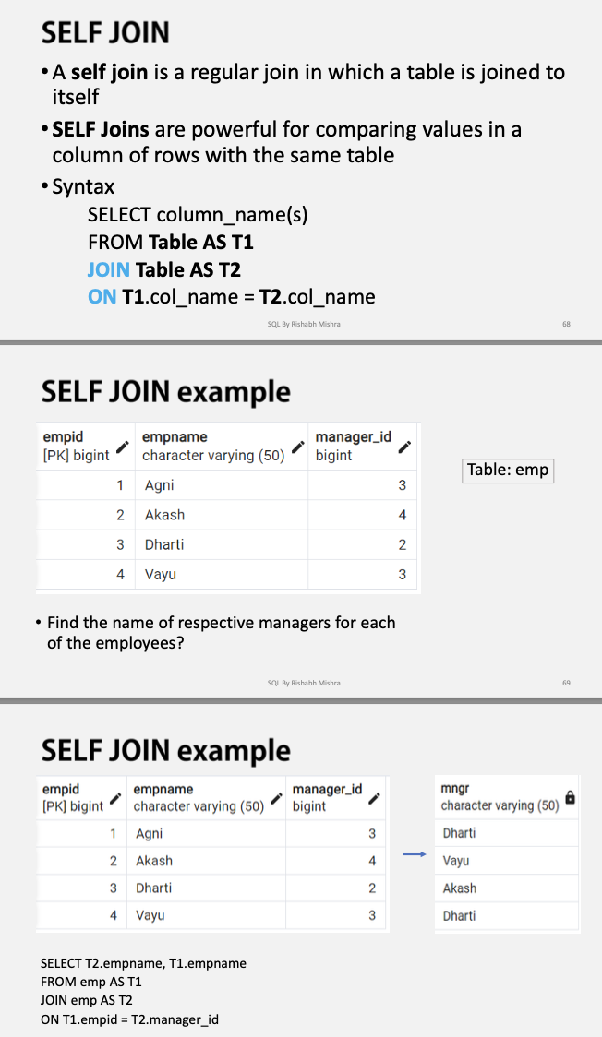

**Union & Union All:**

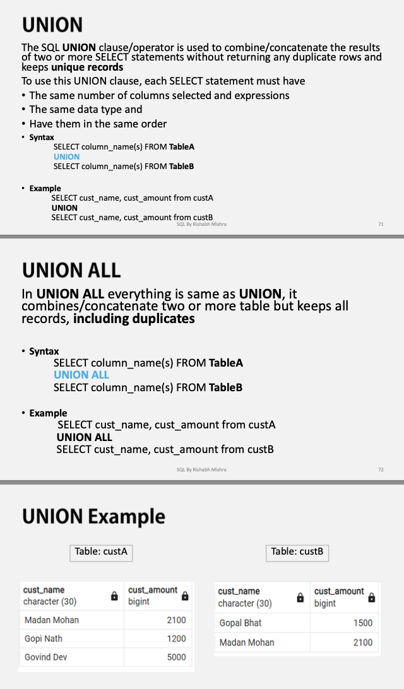

**ANY & ALL:**

### Example 1: Using ANY

The ANY operator is used when you want to compare a value with any value from a set of values returned by a subquery.

#### Example:

Find all employees whose salary is greater than **any** salary of employees in department 10:

sql

Copy

SELECT employee_id, name, salary

FROM employees

WHERE salary > ANY (SELECT salary FROM employees WHERE department_id = 10);

**Explanation**:

* This query returns all employees whose salary is greater than **any** salary in department 10. The condition is true if their salary is greater than at least one of the salaries in that department.

### Example 2: Using ALL

The ALL operator is used when you want to compare a value to **all** values from a set of values returned by a subquery.

#### Example:

Find all employees whose salary is greater than **all** salaries of employees in department 10:

sql

Copy

SELECT employee_id, name, salary

FROM employees

WHERE salary > ALL (SELECT salary FROM employees WHERE department_id = 10);

**Explanation**:

* This query returns employees whose salary is greater than **every single** salary in department 10. The condition is true if their salary is greater than **all** the salaries in that department.

**Sub Query:**

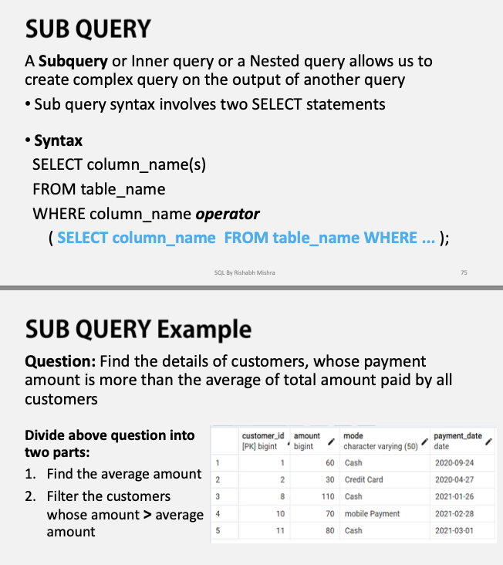

**Window Functions:**

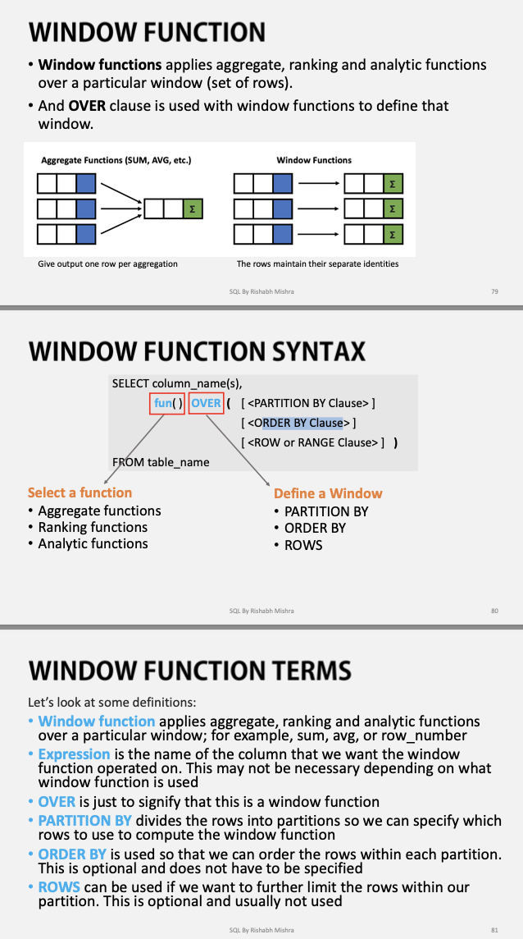

In SQL, especially when working with **window functions**, the terms **UNBOUNDED PRECEDING** and **UNBOUNDED FOLLOWING** are used to define the range of rows that the window function should consider in relation to the current row.

**UNBOUNDED PRECEDING means from beginning to current row**

**UNBOUNDED FOLLOWING:** This means that the window function will consider **all rows following the current row** up to the end of the partition

### Summary:

* **UNBOUNDED PRECEDING**: Refers to the first row in the partition
* **UNBOUNDED FOLLOWING**: Refers to the last row in the partition.

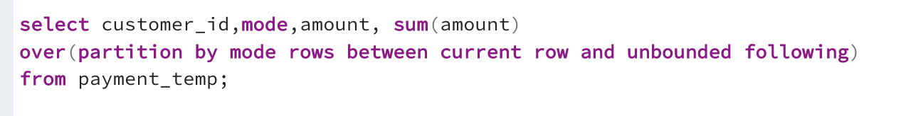

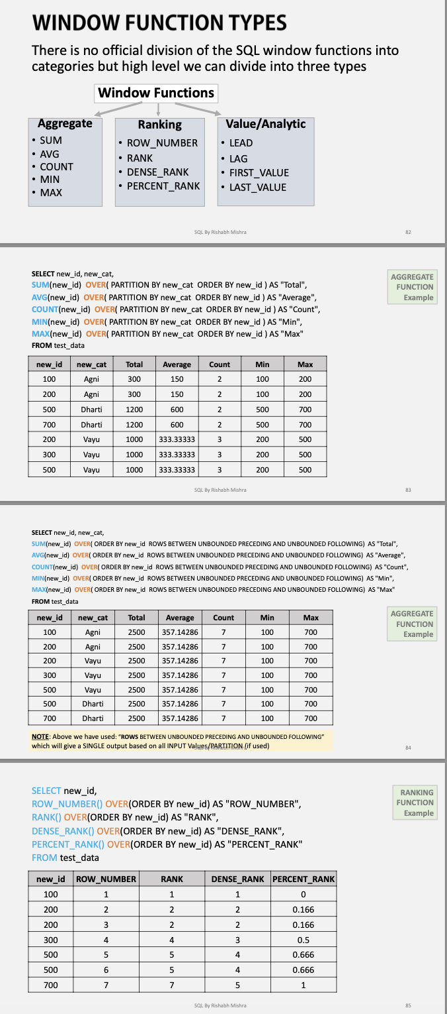

**In case of rank, dense_rank and row_number, column added at first is considered as the refernce column**

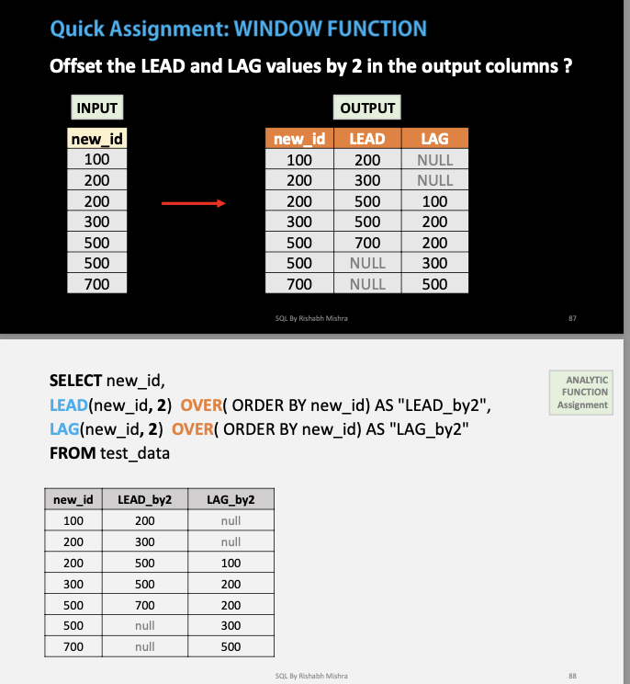

**Case Expressions:**

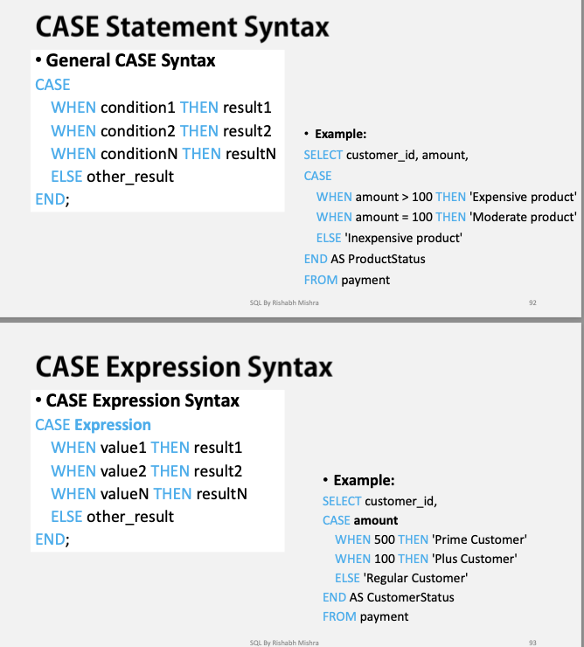

**If Condition:**

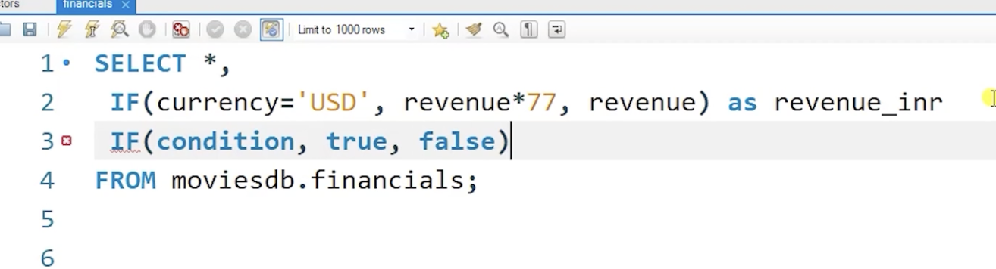

**Common Table Expressions:**

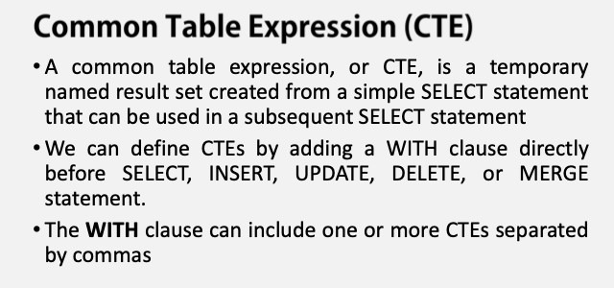

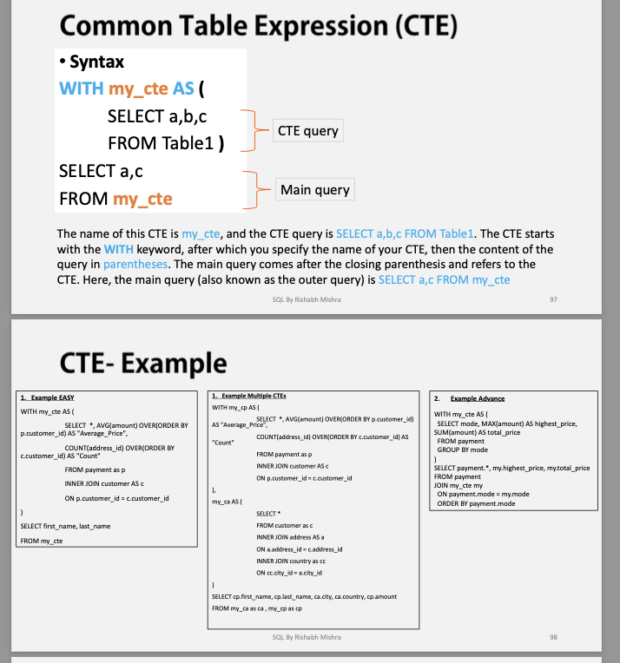

**Recursive CTE:**

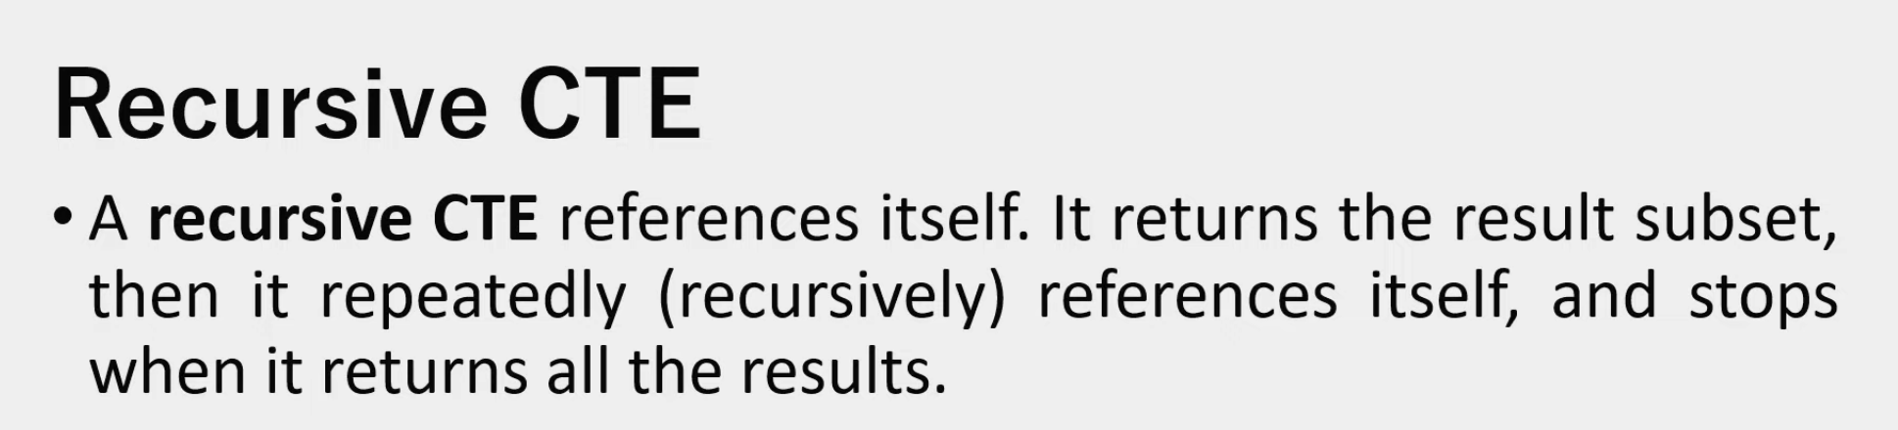

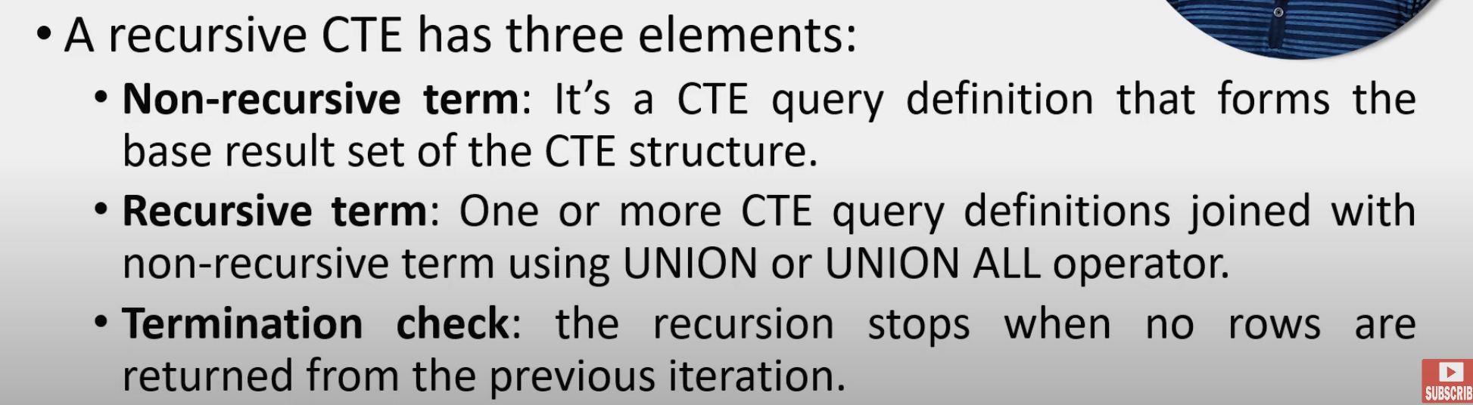

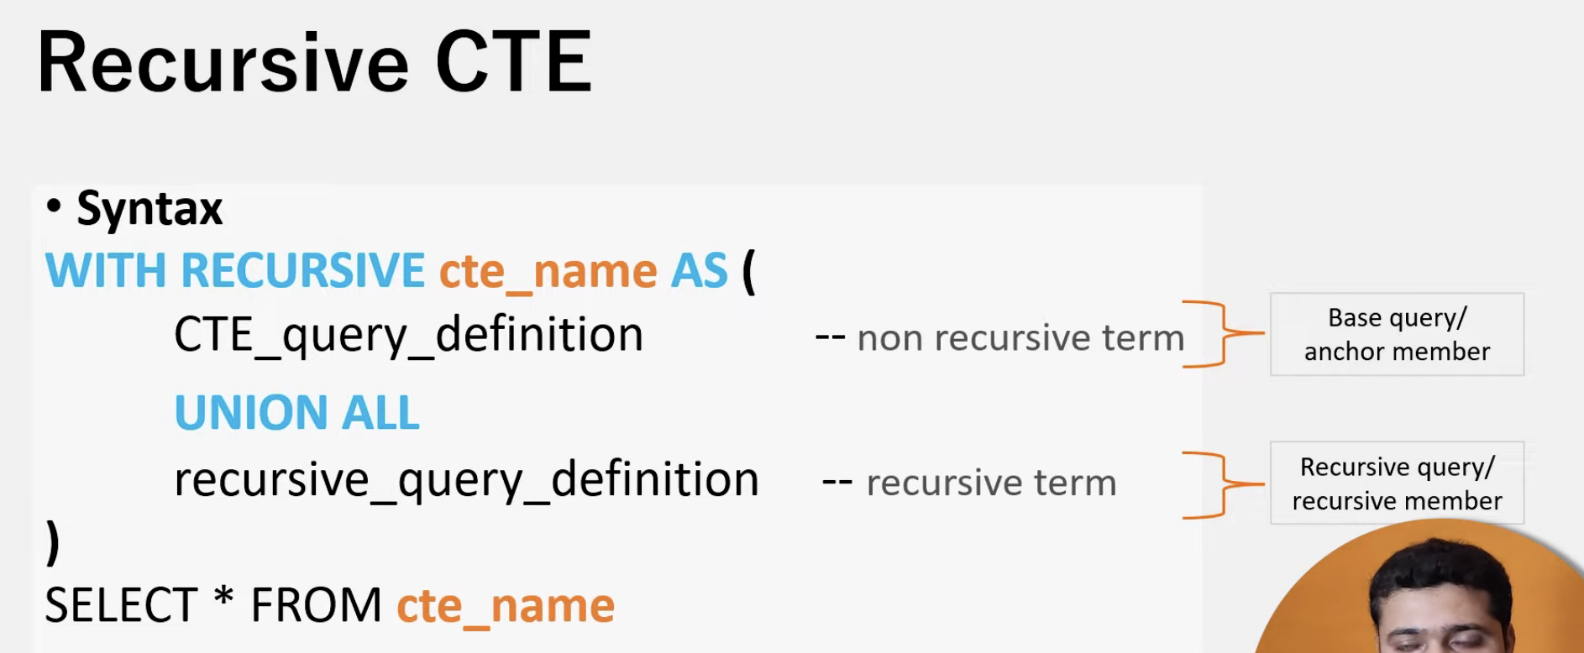

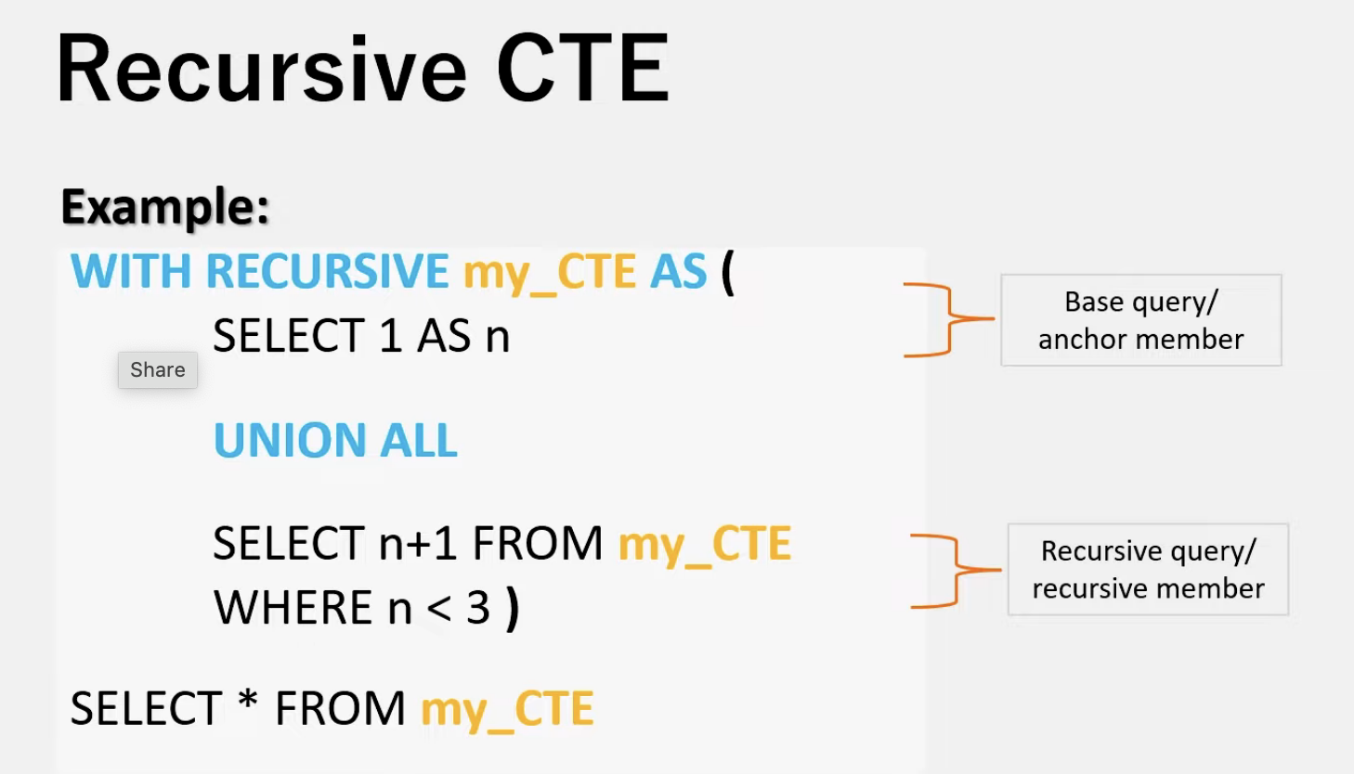

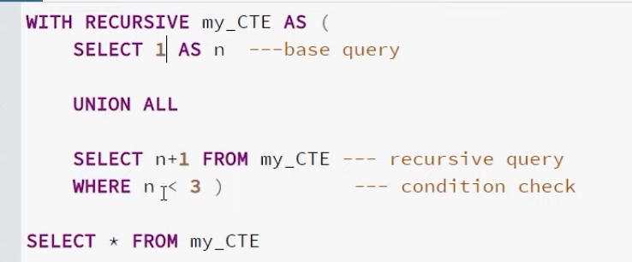

**First base query gets executed and value is 1,**

**Next it will be keep running recursive query till condition is false and n value gets updated based on the the operation in select statement, here n keep incrementing by 1**

**CREATE TABLE employees (**

**emp_id serial PRIMARY KEY,**

**emp_name VARCHAR NOT NULL,**

**manager_id INT**

**);**

**INSERT INTO employees (**

**emp_id, emp_name, manager_id**

**) VALUES**

**(1, 'Madhav', NULL),**

**(2, 'Sam', 1),**

**(3, 'Tom', 2),**

**(4, 'Arjun', 6),**

**(5, 'Shiva', 4),**

**(6, 'Keshav', 1),**

**(7, 'Damodar', 5);**

**WITH RECURSIVE EmpCTE AS (**

**-- Anchor query**

**Select emp_id, emp_name, manager_id**

**From employees**

**Where emp_id = 7**

**UNION ALL**

**-- Recursive query**

**Select employees.emp_id, employees.emp_name, employees.manager_id**

**From employees**

**JOIN EmpCTE**

**ON employees.emp_id = EmpCTE.manager_id**

**)**

**Select * From EmpCTE**

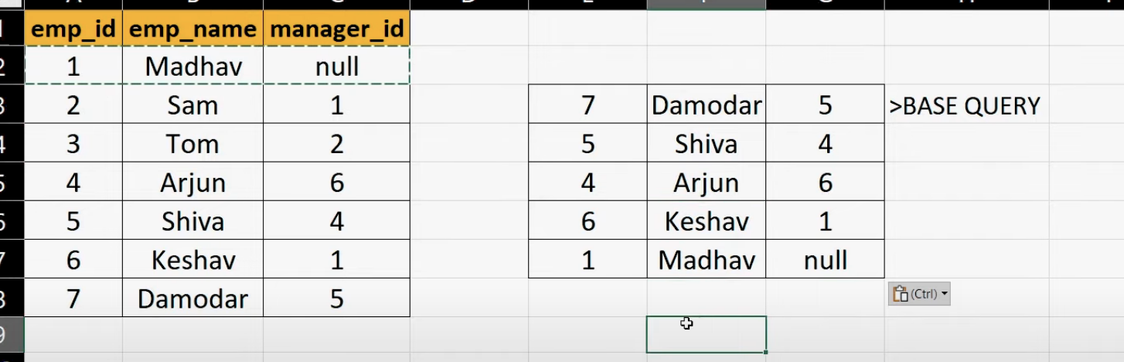

**Stored Procedure:**

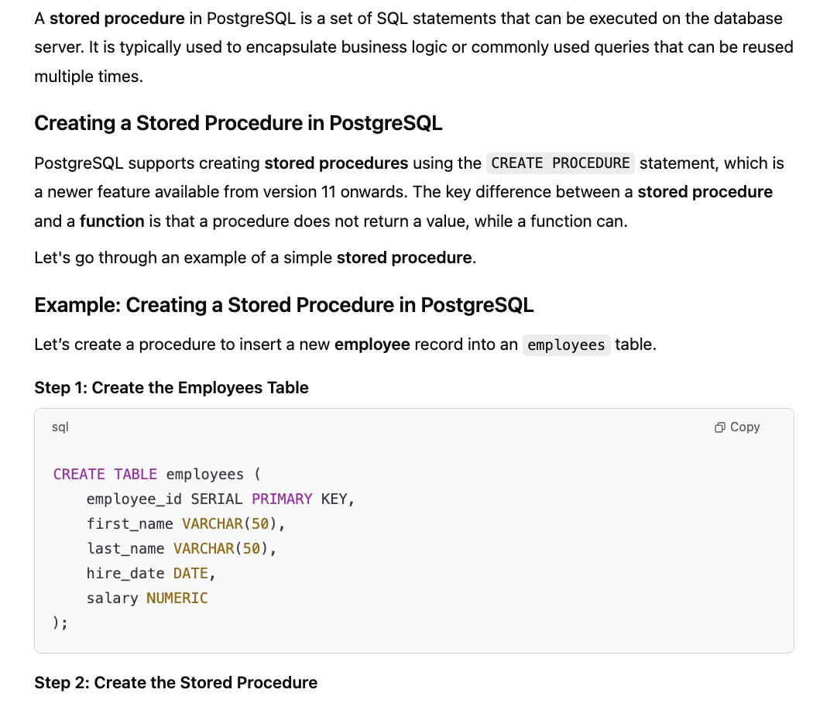

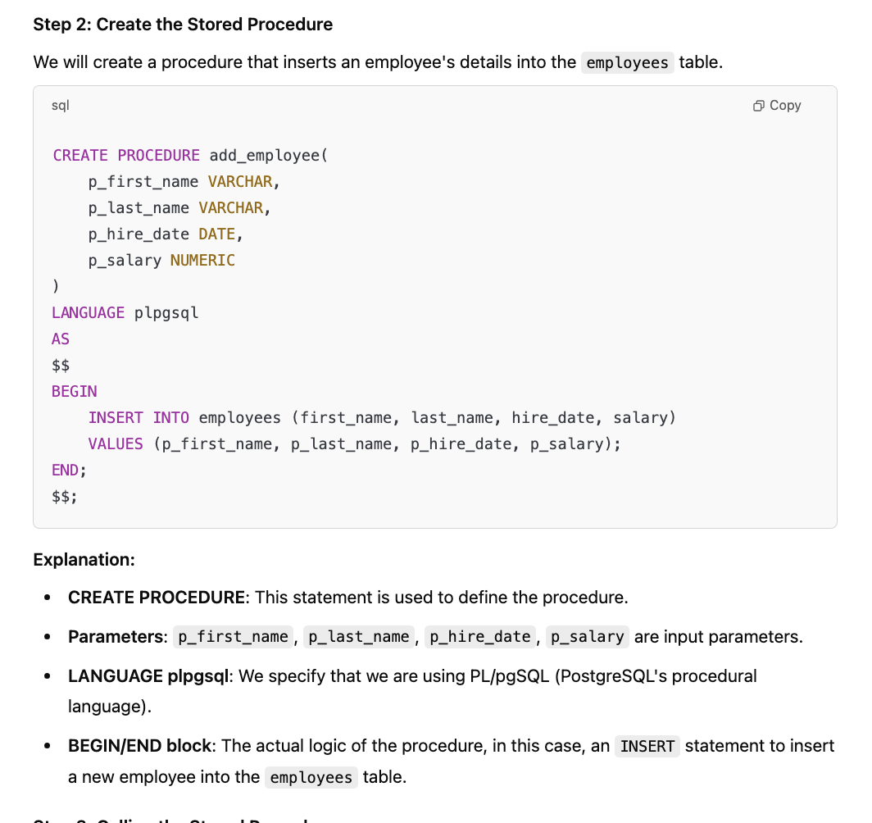

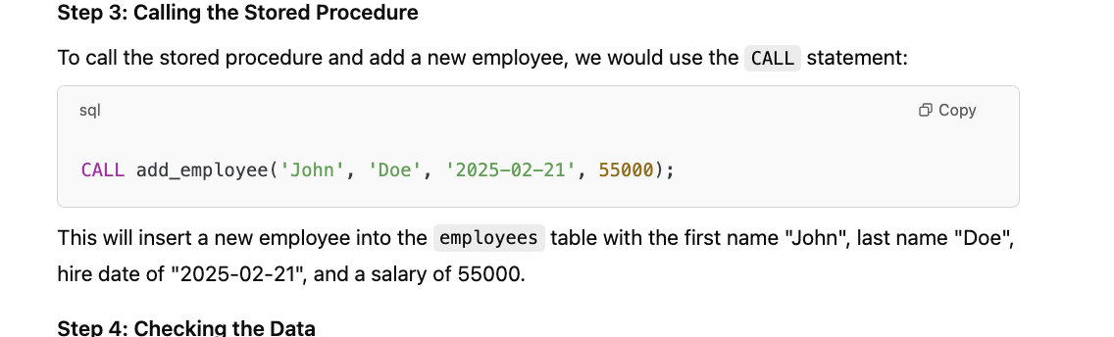

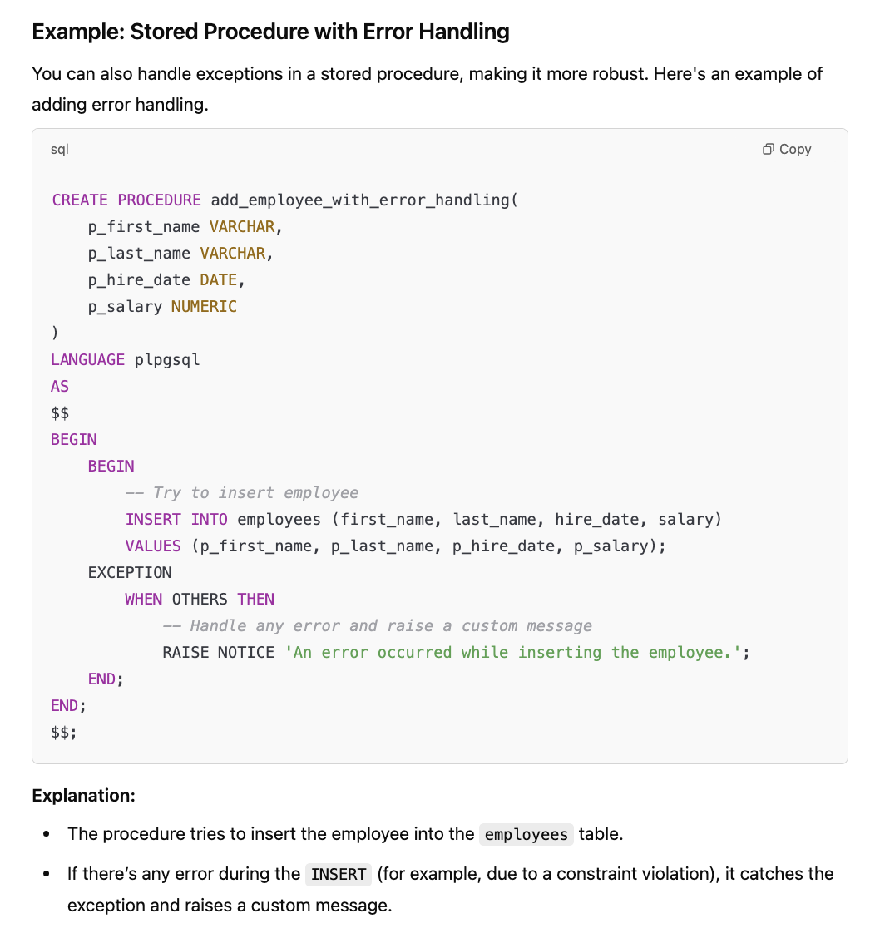

Performance Check

Time take to fecth one row and time taken to fecth all the rows

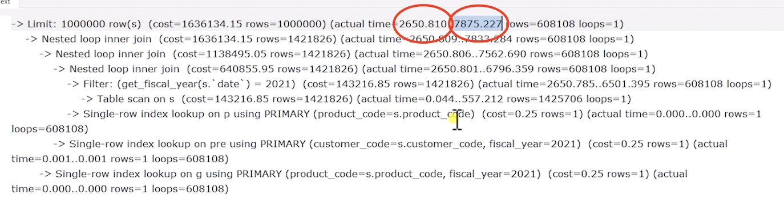

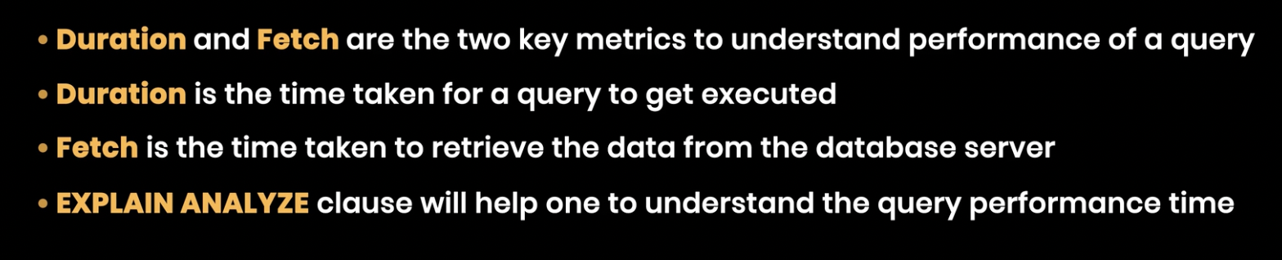

Subquery vs CTE vs Views vs Temp_Table

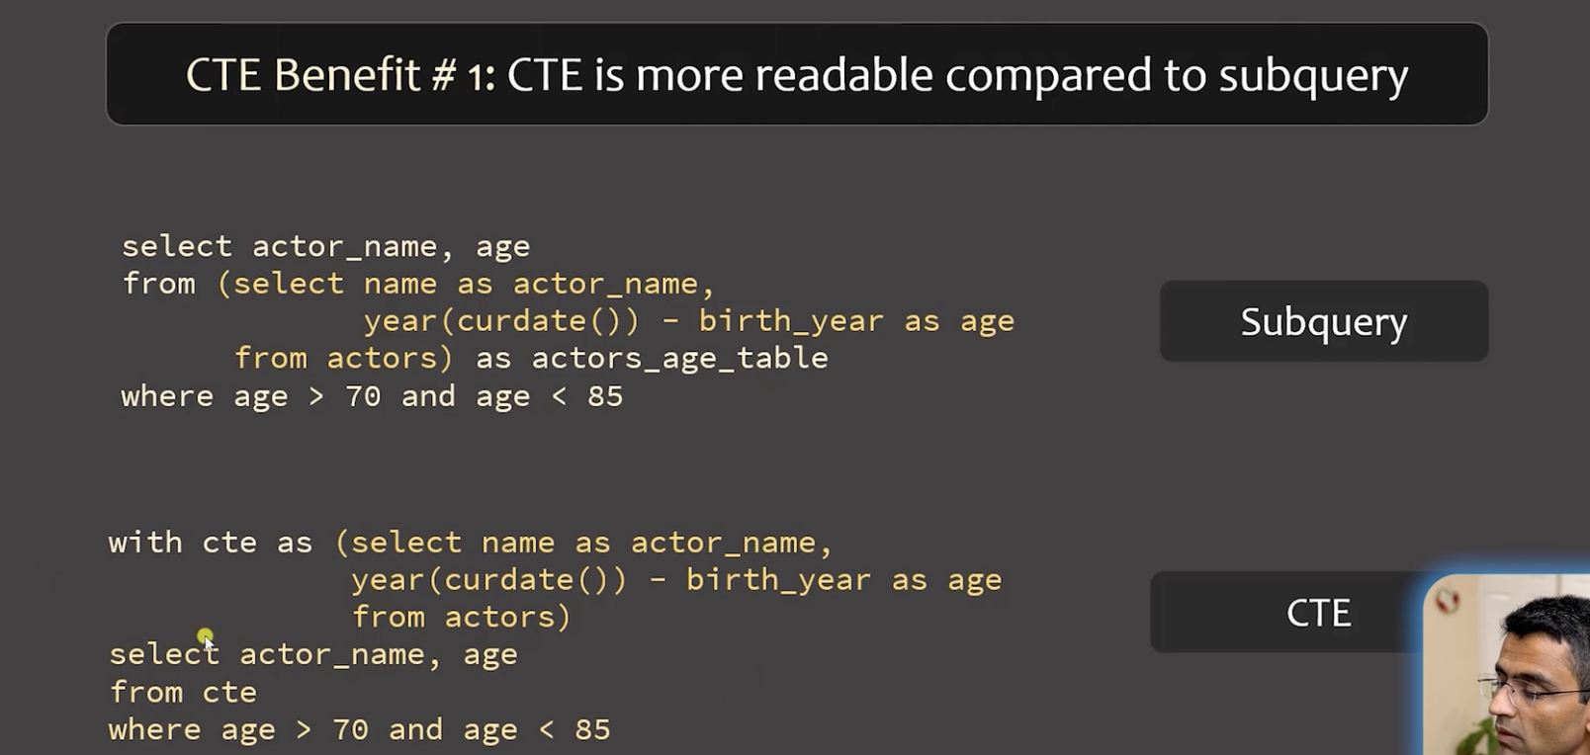 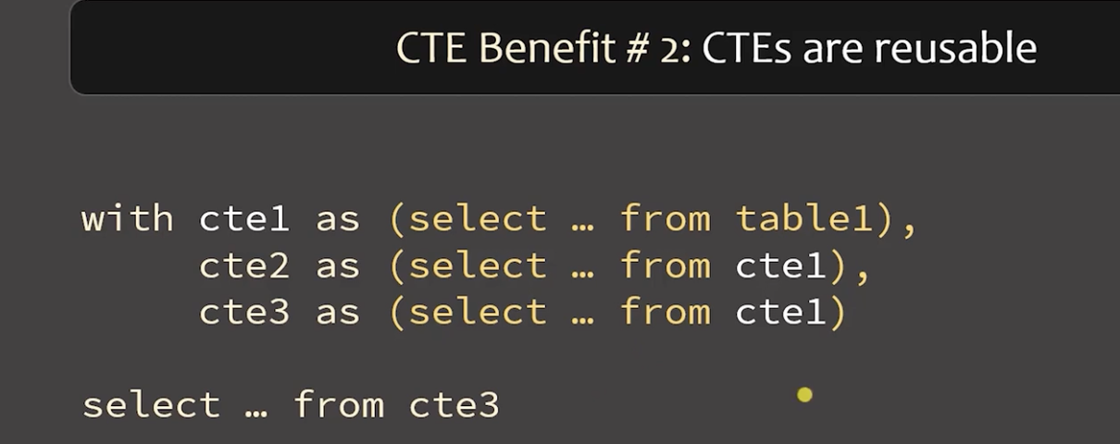

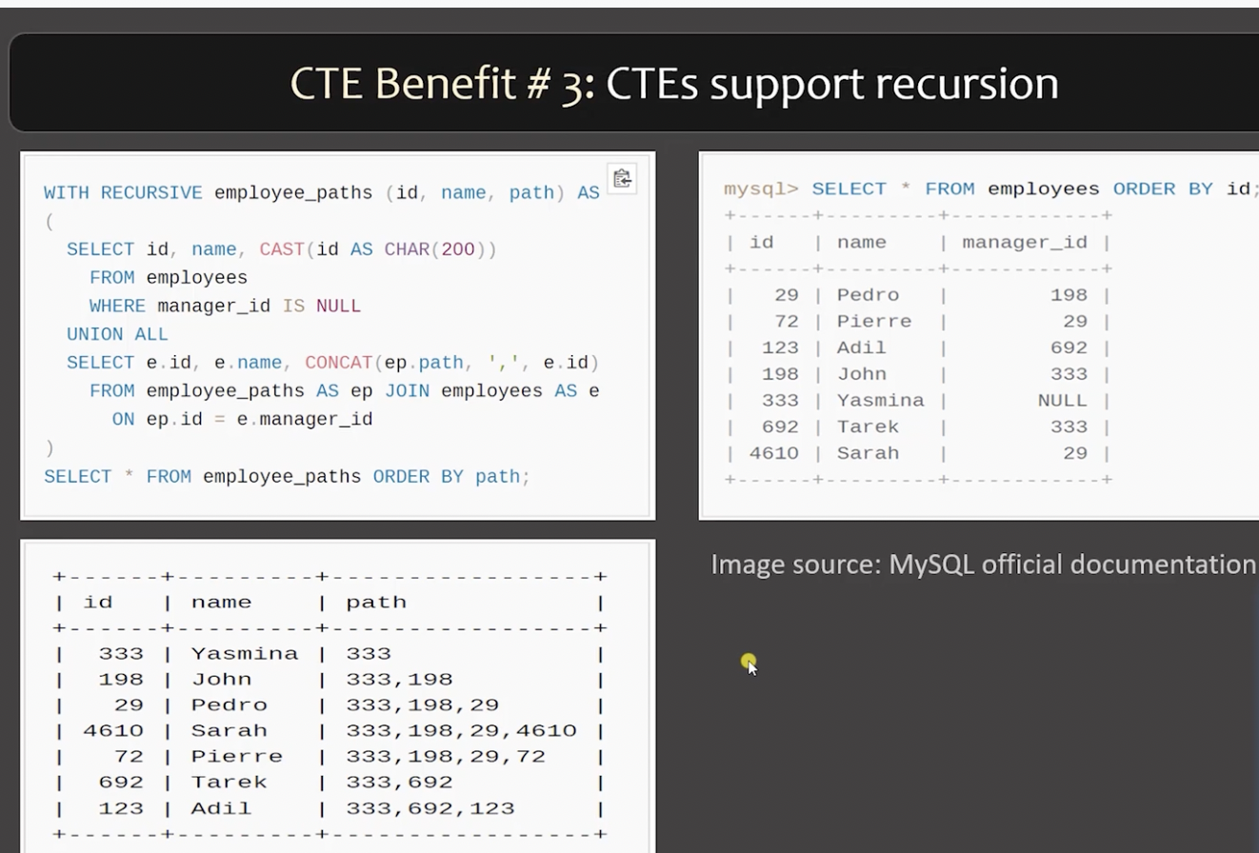

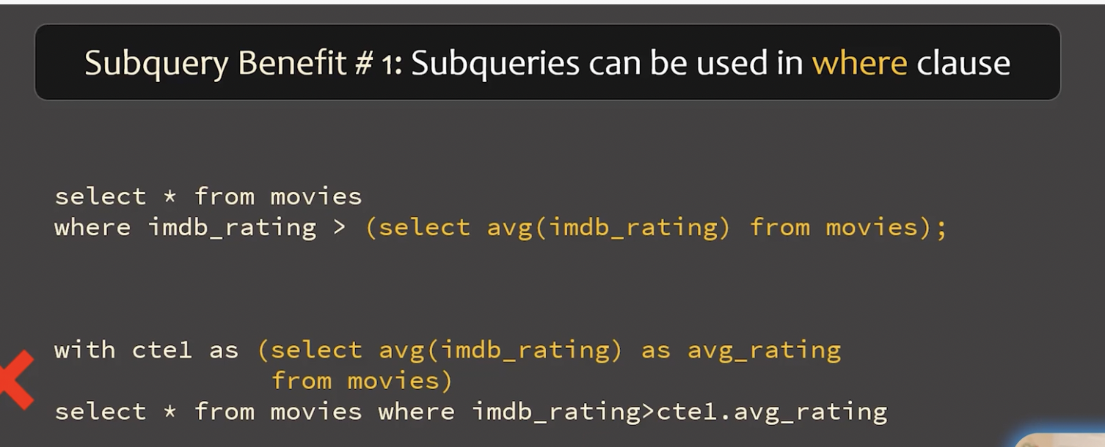

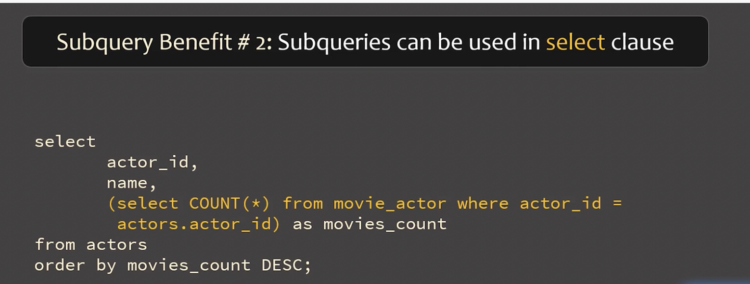

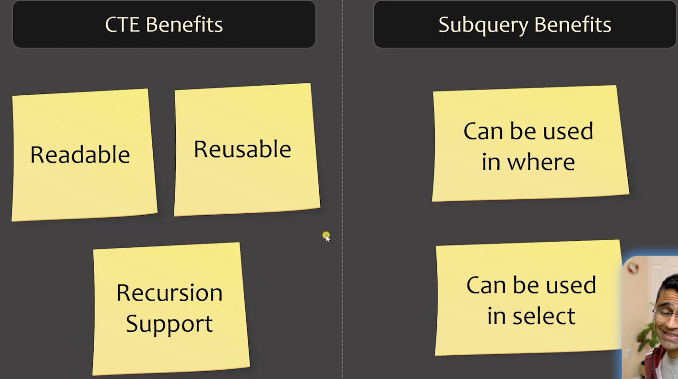

Temporary Table:

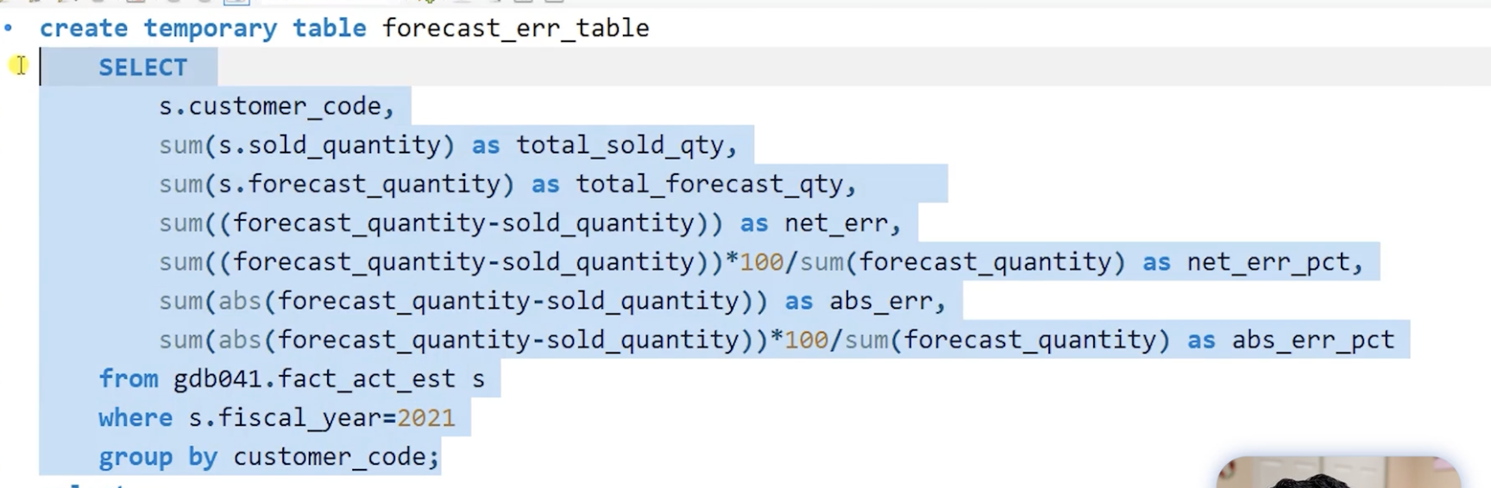

It will be valid only for the session, if workbench is closed and opened again then it is gone

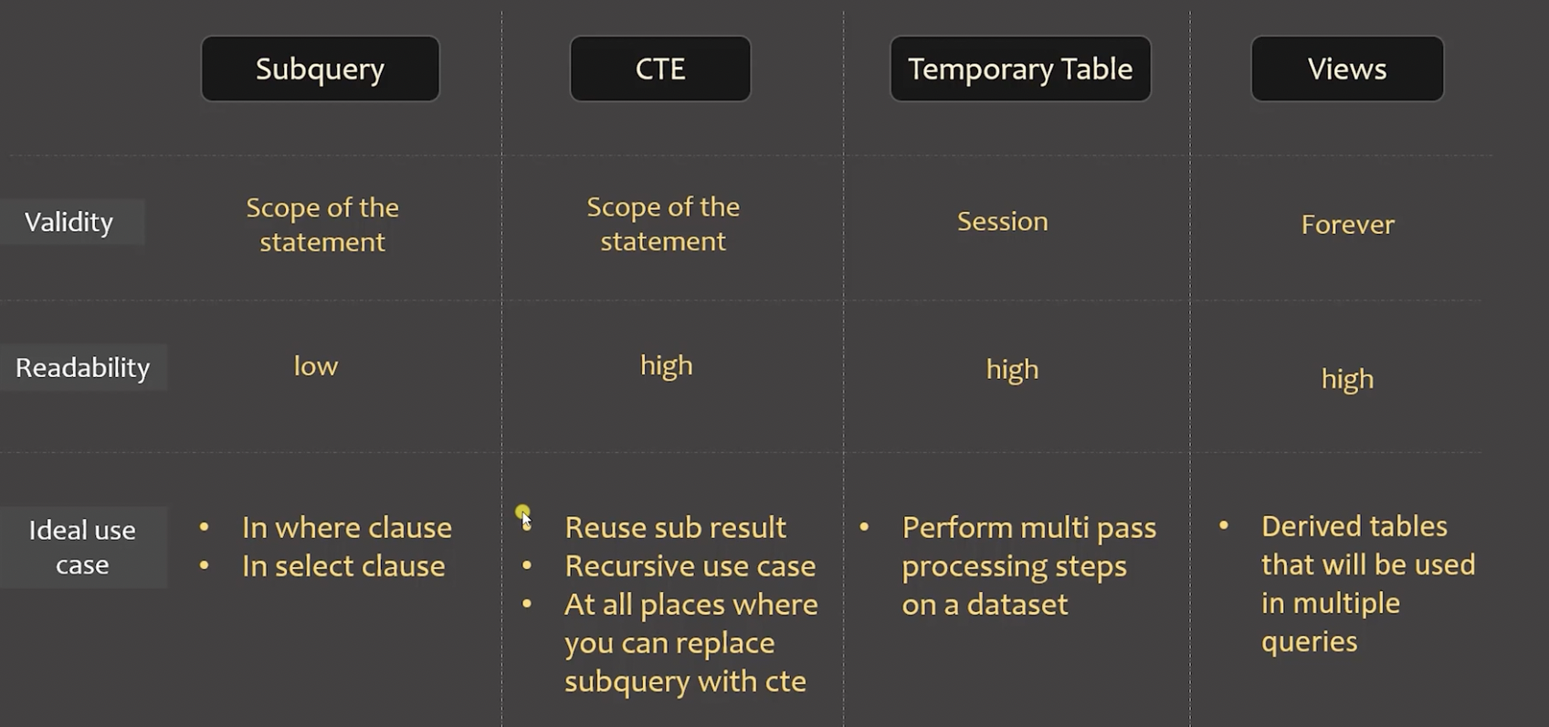

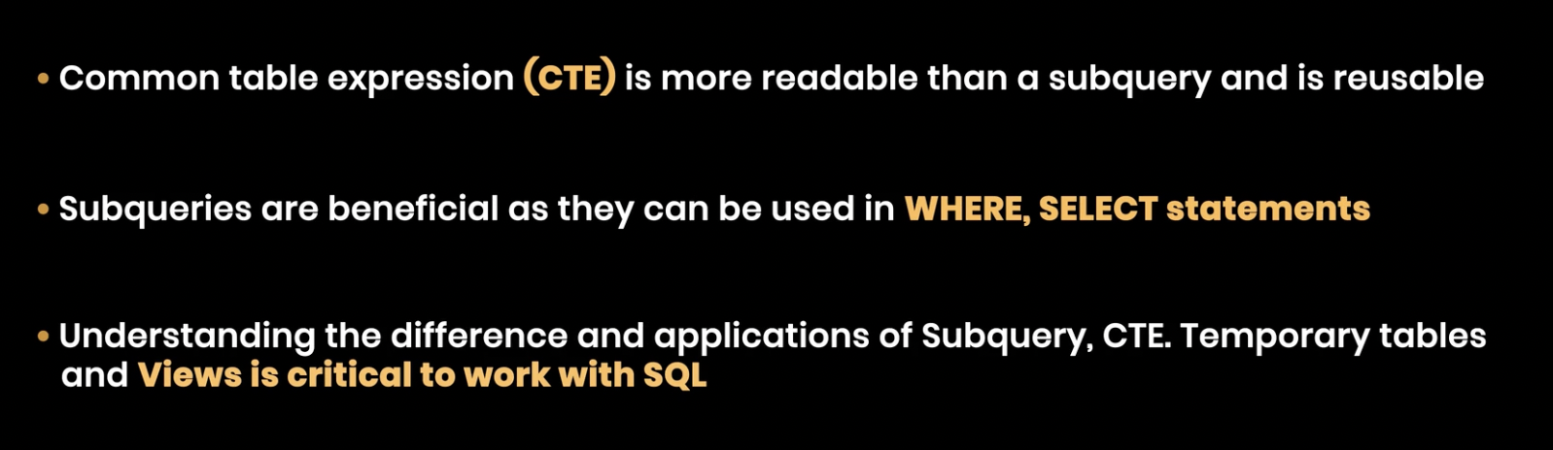

User Session:

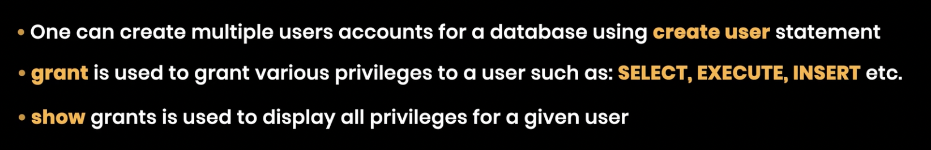

**Triggers and Events:**

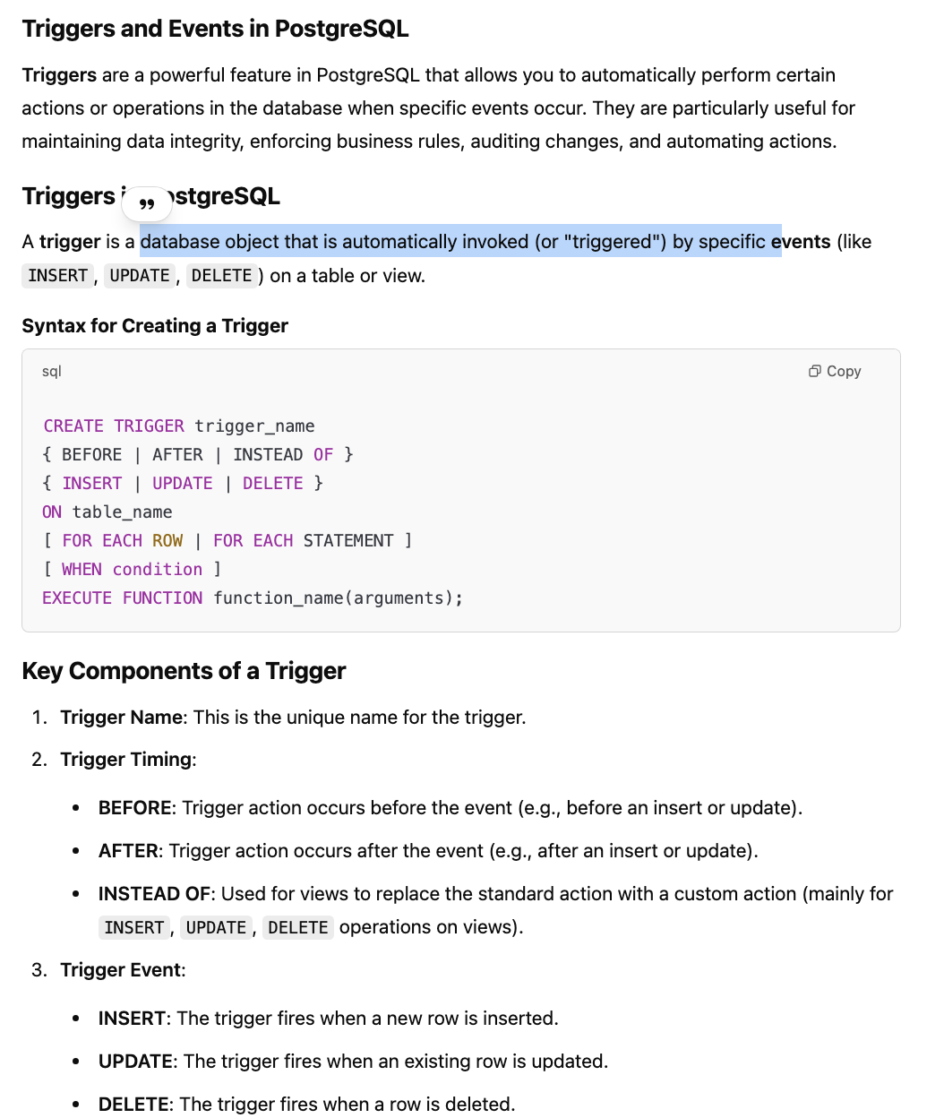

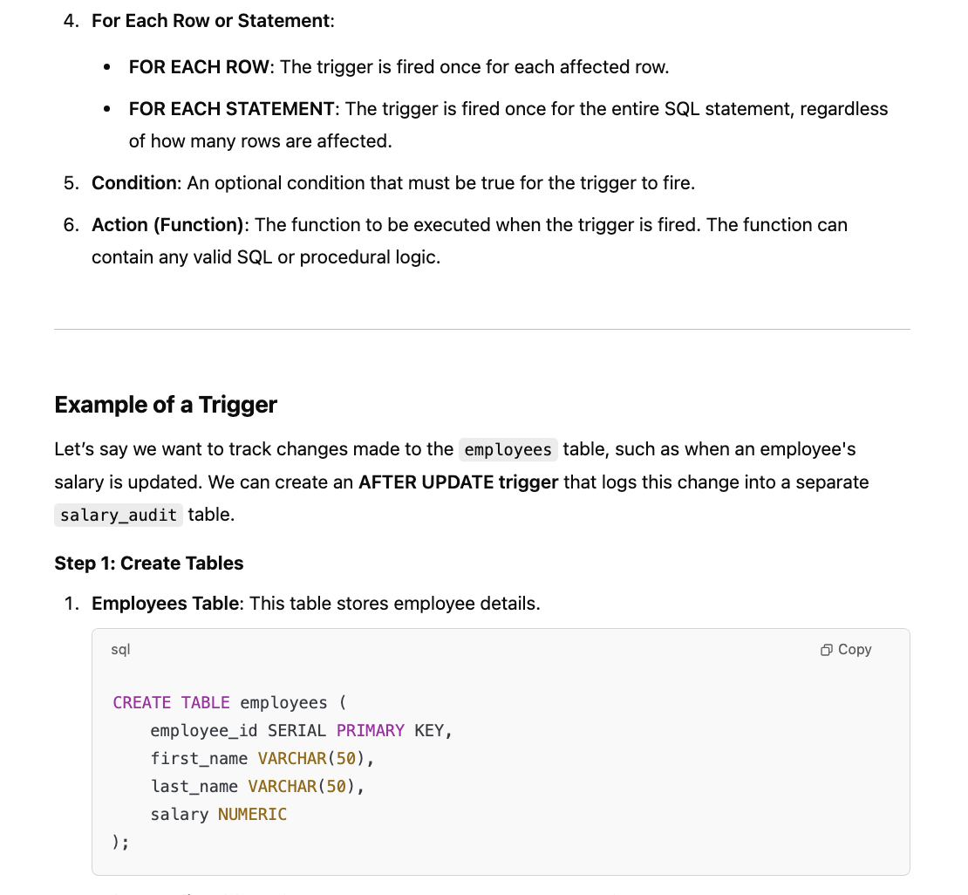

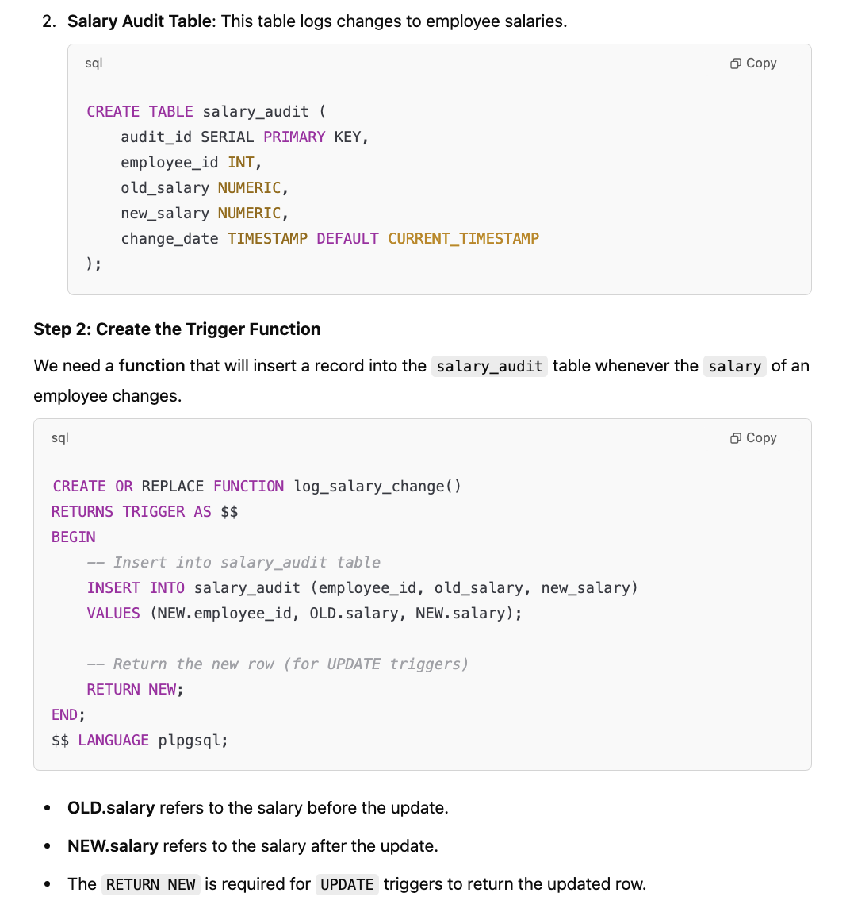

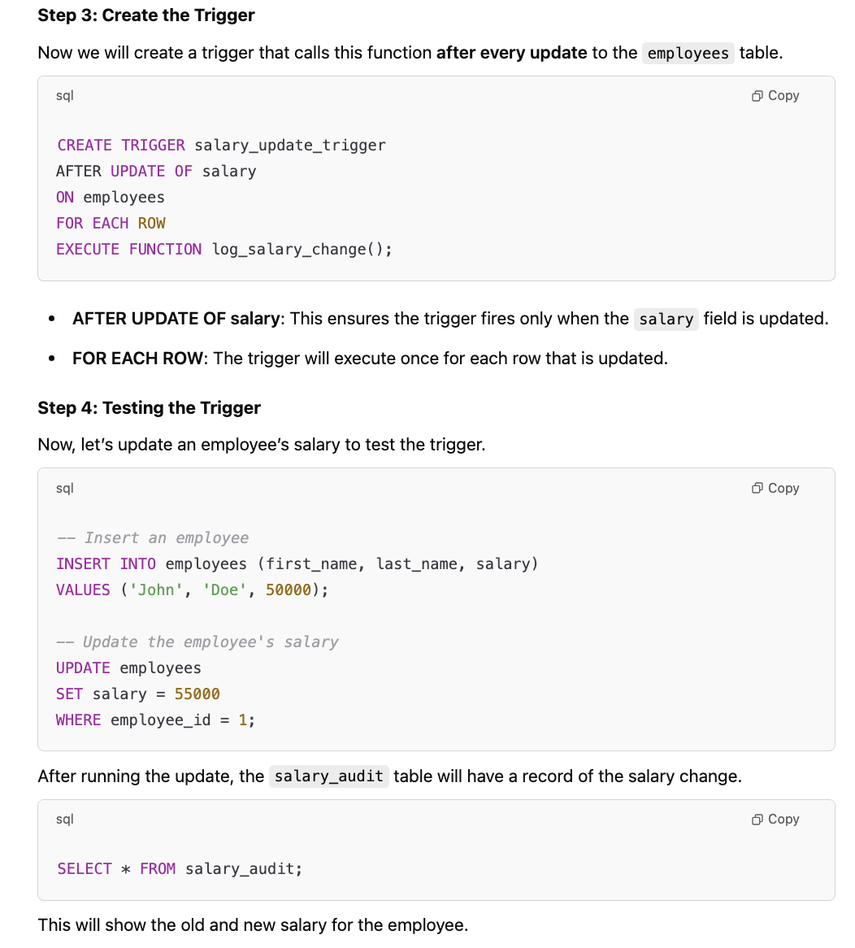

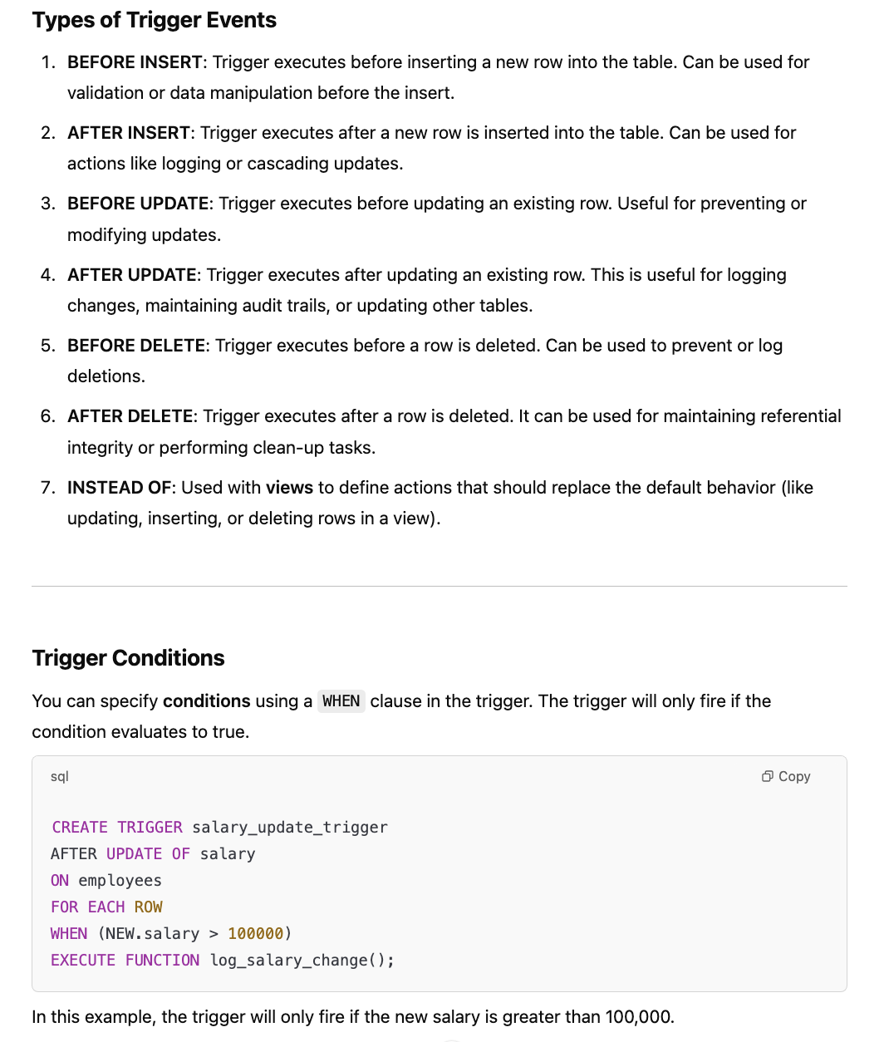

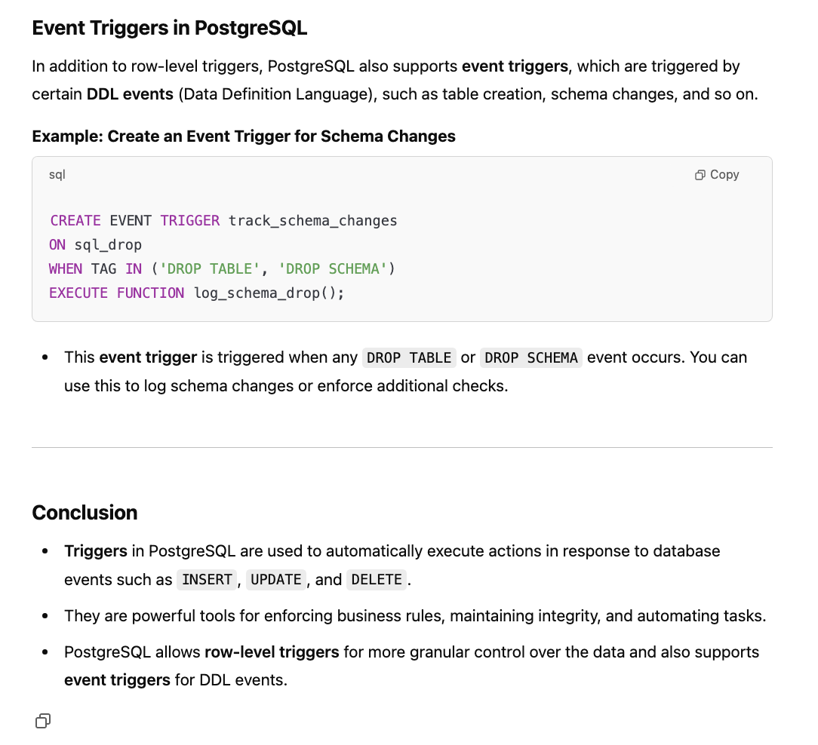

**Views:**

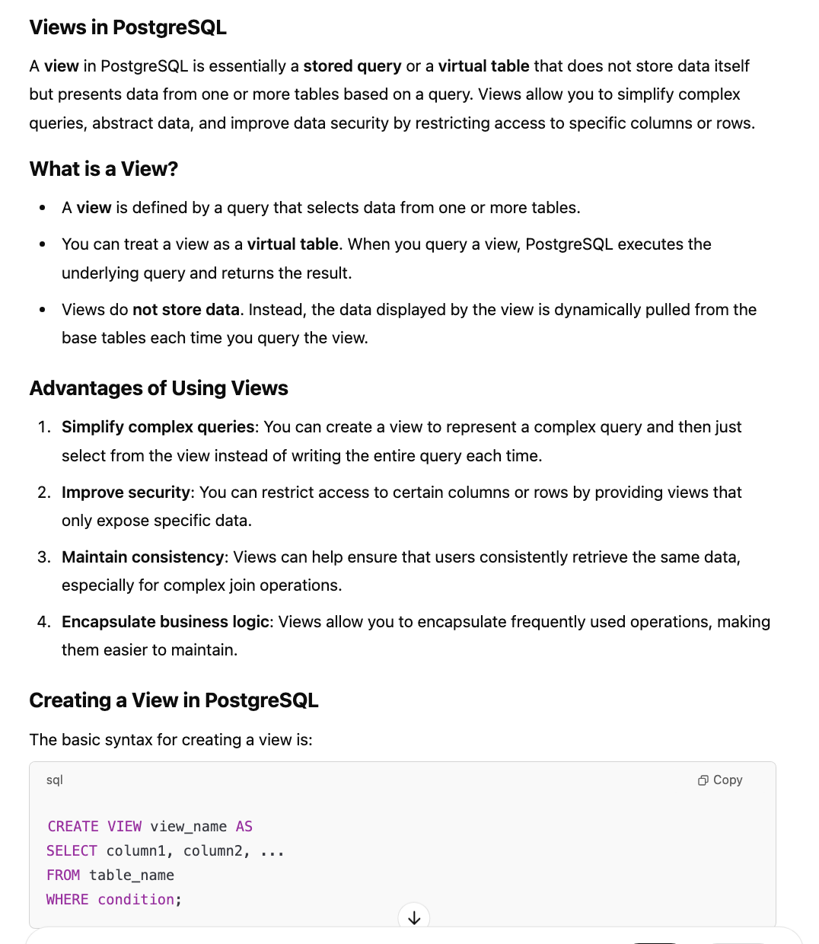

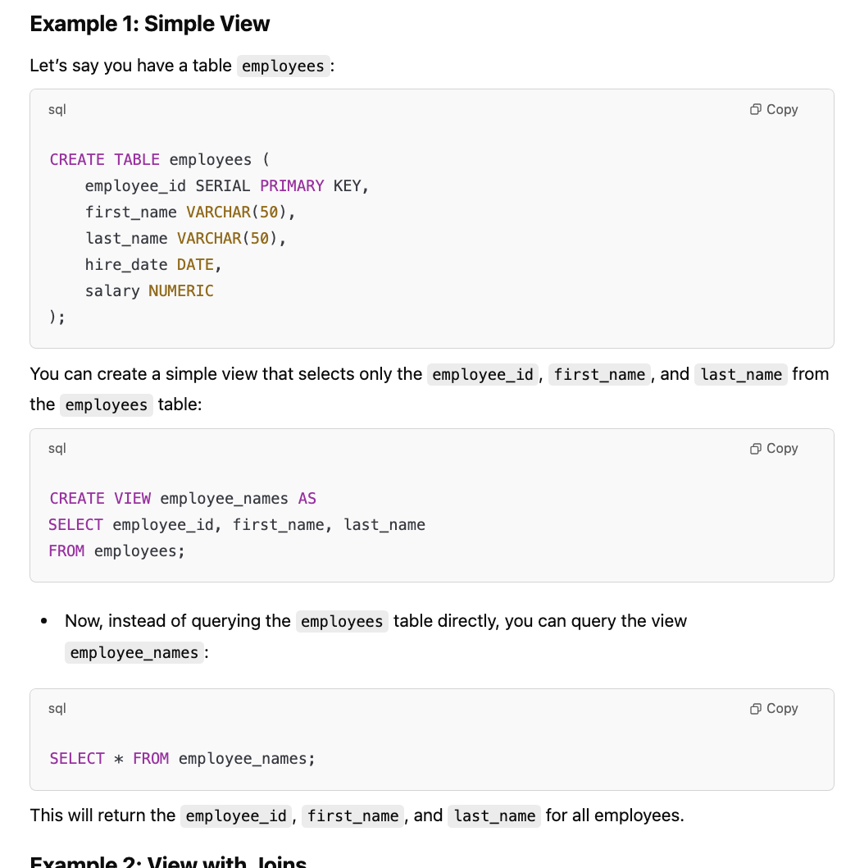

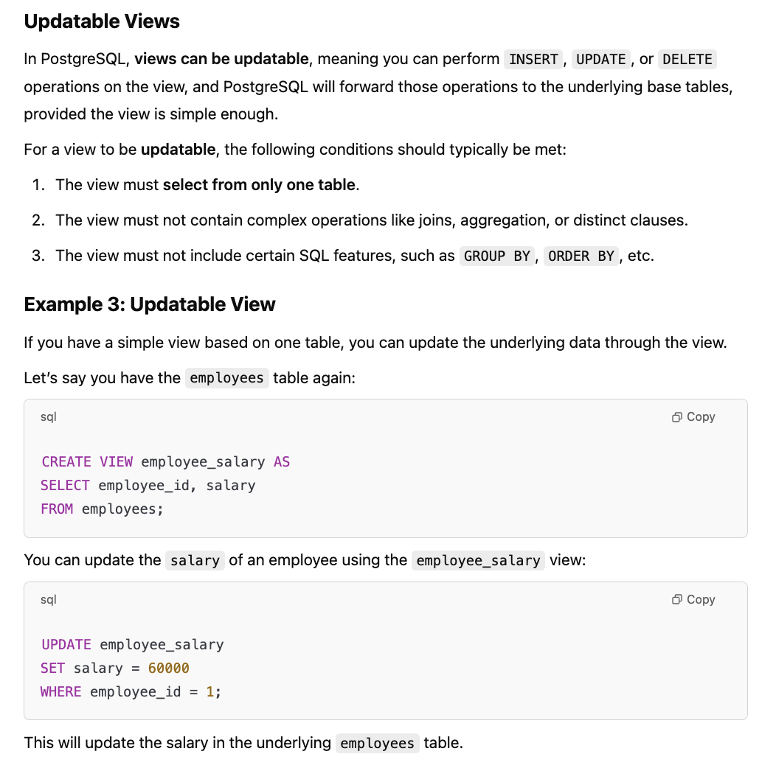

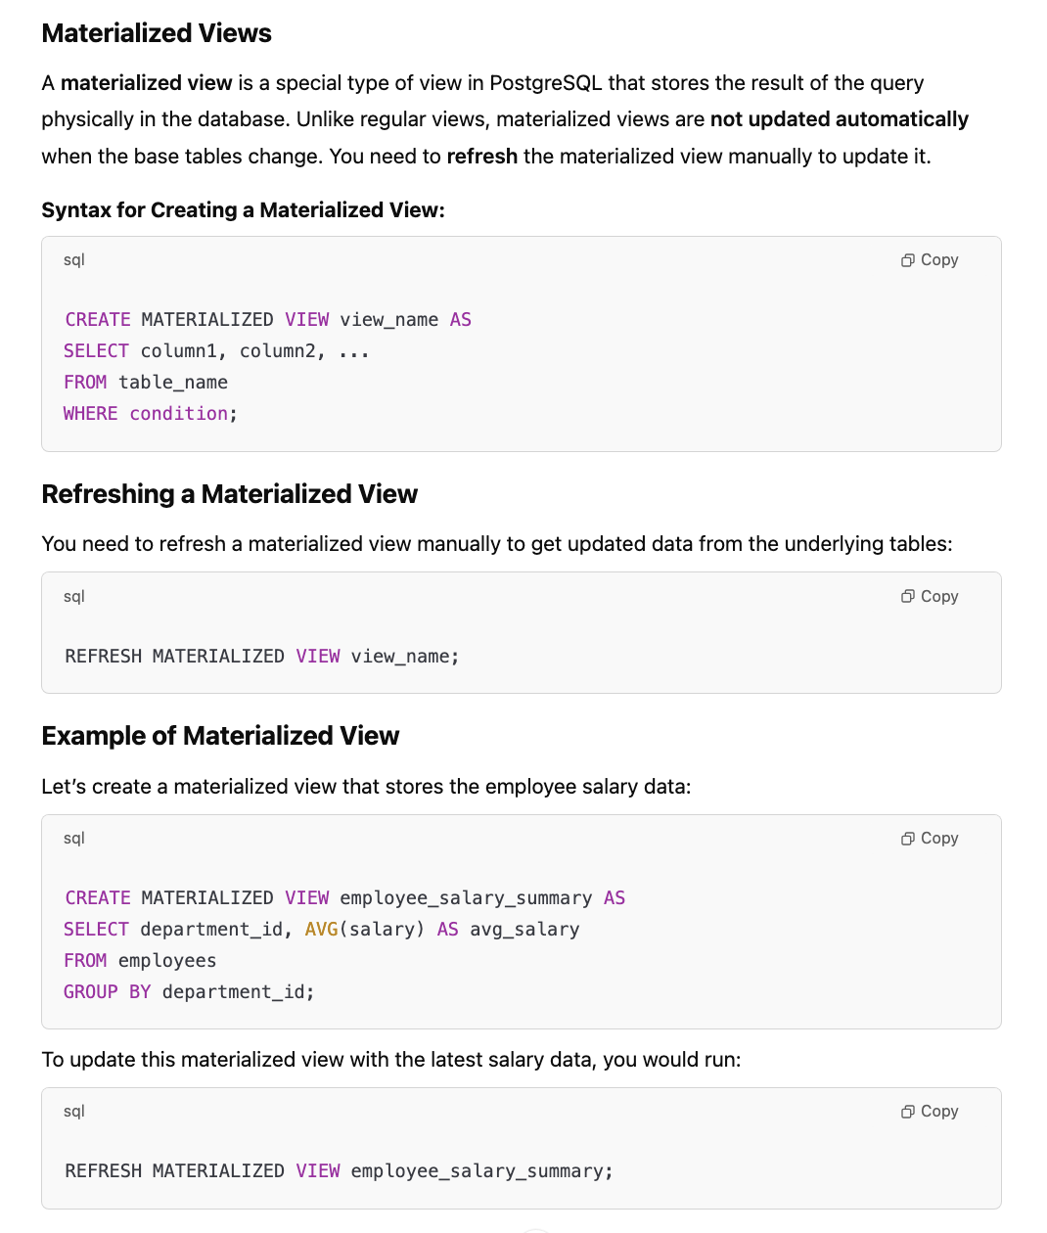

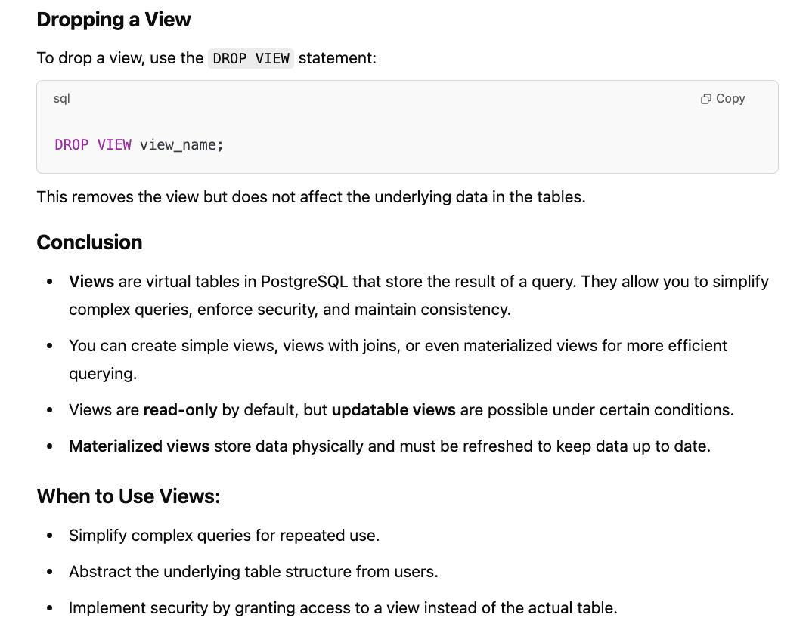

**Indexing:**

DB Indexes:

